Explainable and Uncertainty-Aware Deep Learning for Melanoma Detection:
Multi-Dataset Benchmarking and External Validation

Author and Affiliation
Yati Rastogi
B.Tech, Computer Science and Engineering (Artificial Intelligence and Machine Learning)
JSS University, Noida
Uttar Pradesh, India

Abstract
Melanoma is one of the most aggressive forms of skin cancer, and its early detection is essential for improving patient survival rates. Despite significant advancements in computer-aided diagnosis, the comparative performance of modern deep learning architectures across multiple dermoscopic image datasets remains insufficiently explored. This study presents a comprehensive benchmarking framework for automated melanoma detection using dermoscopic images collected from three publicly available datasets: HAM10000, ISIC2018, and PH2. A standardized preprocessing pipeline involving image normalization, contrast enhancement, and data augmentation was applied to improve image quality and model generalization.
Six deep learning architectures, namely EfficientNetV2, DenseNet121, ResNet101, ConvNeXt Tiny, Swin Transformer, and MedFairXNet, were evaluated using a consistent experimental setup. Model performance was assessed using Accuracy, Precision, Sensitivity, F1-Score, and Area Under the Receiver Operating Characteristic Curve (ROC-AUC). Experimental results demonstrated that all benchmark models achieved strong classification performance across the datasets, with EfficientNetV2 and ResNet101 consistently providing competitive results. On the PH2 dataset, ResNet101 achieved an Accuracy of 93.33% and a ROC-AUC of 98.61%, while EfficientNetV2 achieved an Accuracy of 93.33% and a ROC-AUC of 97.22%. Initial experiments on the ISIC2018 dataset using EfficientNetV2 achieved an Accuracy of 92.68% and a ROC-AUC of 93.43%.
The findings indicate that deep learning-based approaches can effectively support automated melanoma screening and decision support. Furthermore, the developed framework provides a robust basis for real-world deployment through an interactive web-based diagnostic application and offers valuable insights for future research in AI-assisted skin cancer detection.
Keywords: Melanoma Detection, Deep Learning, Dermoscopic Images, EfficientNetV2, ResNet101, DenseNet121, Swin Transformer, Medical Image Analysis, Skin Cancer Classification.

1. Introduction
1.1 Clinical Problem
Melanoma is one of the most aggressive and life-threatening forms of skin cancer, originating from melanocytes, the pigment-producing cells of the skin. Although melanoma accounts for a smaller proportion of total skin cancer cases compared to basal cell carcinoma and squamous cell carcinoma, it is responsible for the majority of skin cancer-related deaths due to its high metastatic potential. According to global cancer statistics, the incidence of melanoma has increased steadily over the past decades, creating a significant public health burden worldwide.
Early diagnosis plays a crucial role in improving patient survival rates. When detected in its initial stages, melanoma can often be treated successfully through surgical excision, resulting in survival rates exceeding 90%. However, delayed diagnosis substantially increases the risk of metastasis, reducing treatment effectiveness and patient prognosis. Accurate identification of melanoma remains challenging because malignant lesions frequently exhibit visual characteristics that overlap with benign skin lesions such as nevi and seborrheic keratoses.
Dermoscopy has emerged as a widely adopted non-invasive imaging technique that enhances the visualization of subsurface skin structures and improves diagnostic accuracy compared with conventional visual inspection. Nevertheless, dermoscopic interpretation requires extensive clinical expertise and remains subject to inter-observer variability. The increasing demand for dermatological screening, coupled with the limited availability of trained specialists, has motivated the development of automated computer-aided diagnostic systems capable of assisting clinicians in melanoma detection.
1.2 Artificial Intelligence in Dermoscopic Image Analysis
Recent advancements in artificial intelligence, particularly deep learning, have significantly transformed medical image analysis. Convolutional Neural Networks (CNNs) have demonstrated remarkable performance in visual recognition tasks and have been extensively applied to dermoscopic image classification. Architectures such as ResNet, DenseNet, Inception, and EfficientNet have achieved competitive performance in melanoma detection by automatically learning hierarchical visual representations directly from image data.
The availability of large-scale public datasets, including HAM10000, ISIC2018, and PH2, has accelerated research in automated skin lesion analysis. These datasets provide annotated dermoscopic images that facilitate supervised learning and benchmarking of classification algorithms. Deep learning models trained on such datasets have frequently reported diagnostic performance comparable to or exceeding that of experienced dermatologists under controlled experimental conditions.
More recently, transformer-based architectures have been introduced into medical image analysis. Vision Transformers and Swin Transformers utilize self-attention mechanisms to capture long-range dependencies and global contextual information that may not be effectively modeled by conventional CNNs. These architectures have demonstrated promising results across various medical imaging applications, including skin lesion classification, radiology, pathology, and ophthalmology.
In addition to classification, researchers have explored segmentation-driven frameworks that first localize lesion boundaries before performing diagnostic classification. Segmentation techniques, including U-Net and attention-based segmentation networks, aim to isolate lesion regions and reduce the influence of irrelevant background information. Such approaches can potentially improve classification performance by focusing model attention on clinically relevant structures.
1.3 Existing Computational Limitations
Despite significant progress, several computational challenges continue to limit the reliable deployment of artificial intelligence systems in clinical melanoma screening.
One major limitation of CNN-based models is their restricted receptive field and local feature extraction mechanism. Although CNNs excel at identifying texture and morphological patterns, they may struggle to capture global contextual relationships that are clinically relevant for lesion assessment. Consequently, their performance may degrade when confronted with highly heterogeneous lesion appearances.
Transformer-based architectures address some of these limitations through self-attention mechanisms; however, they typically require substantially larger datasets and computational resources for effective training. Medical imaging datasets are often considerably smaller than natural image datasets, increasing the risk of overfitting and unstable generalization.
Another challenge arises from lesion segmentation. While segmentation can improve interpretability and classification performance, accurate lesion boundary delineation remains difficult in the presence of low contrast, hair occlusion, imaging artifacts, and irregular lesion structures. Errors introduced during segmentation may propagate into downstream classification tasks.
Dataset imbalance represents a persistent problem in melanoma research. In many publicly available datasets, benign lesions significantly outnumber melanoma cases. Such imbalance may bias learning algorithms toward majority classes, leading to inflated accuracy while reducing sensitivity toward clinically important malignant lesions.
Domain shift further complicates model generalization. Differences in imaging devices, acquisition protocols, patient demographics, illumination conditions, and lesion distributions can cause significant performance degradation when models are evaluated on external datasets. A model trained on one dataset may therefore fail to maintain its performance when deployed in a different clinical environment.
Explainability remains another critical concern. Deep learning models often function as black-box systems, making it difficult for clinicians to understand the rationale behind individual predictions. The lack of transparency can reduce trust and hinder clinical adoption.
Calibration and uncertainty estimation are also frequently overlooked. Many deep learning models produce highly confident predictions even when they are incorrect. Poorly calibrated confidence scores may create false assurance in high-risk clinical scenarios. Similarly, uncertainty information is essential for identifying cases where automated predictions should be reviewed by human experts.
Finally, fairness has emerged as an increasingly important consideration. Variations in skin tone, demographic representation, and dataset composition can introduce biases that affect model performance across different patient populations. Failure to address such biases may lead to inequitable healthcare outcomes.
1.4 Literature Gap
Existing studies have primarily focused on maximizing classification accuracy within individual datasets using isolated model architectures. While numerous investigations have reported strong performance for CNN-based and transformer-based approaches, comparatively fewer studies have conducted systematic benchmarking across multiple independent datasets using consistent preprocessing, training, and evaluation protocols.
Furthermore, many published works evaluate models using a single dataset, limiting insights into cross-dataset generalization and robustness. Reported performance metrics often emphasize accuracy while providing limited analysis of sensitivity, calibration behavior, uncertainty estimation, or external validation. Consequently, it remains difficult to determine whether observed performance improvements reflect genuine model robustness or dataset-specific optimization.
Another methodological gap concerns the comparative assessment of modern CNN architectures and transformer-based architectures under identical experimental settings. Differences in preprocessing pipelines, data splits, augmentation strategies, and evaluation procedures frequently prevent fair comparison between competing approaches. As a result, the relative strengths and limitations of these architectures for melanoma detection remain insufficiently understood.
Therefore, there is a need for a comprehensive multi-dataset benchmarking framework that evaluates diverse deep learning architectures using standardized experimental protocols and clinically relevant evaluation metrics.
1.5 Research Objective
The primary objective of this study is to investigate the effectiveness of multiple deep learning architectures for automated melanoma detection using dermoscopic images obtained from publicly available datasets. The study aims to perform a systematic comparative evaluation of convolutional neural networks and transformer-based architectures under a unified experimental framework. Furthermore, the study seeks to analyze model performance across multiple datasets to assess robustness, generalization capability, and practical applicability in computer-aided dermatological screening systems.

1.6 Research Questions The present study addresses the following research questions:
RQ1: How does the proposed architecture compare with established CNN and transformer benchmarks for melanoma classification?
RQ2: Does model performance generalize effectively across independent dermoscopic image datasets?
RQ3: Which architectural characteristics contribute most significantly to classification performance and robustness?
RQ4: How do different architectures compare in terms of sensitivity, precision, F1-score, and ROC-AUC?
RQ5: What insights can be obtained regarding the strengths and limitations of deep learning architectures through cross-dataset evaluation?
1.7 Contributions
The major contributions of this study are summarized as follows:
- A comprehensive melanoma detection framework is developed using multiple publicly available dermoscopic image datasets, including HAM10000, ISIC2018, and PH2.
- A standardized preprocessing and evaluation pipeline is established to ensure fair comparison among different deep learning architectures.
- Multiple state-of-the-art CNN and transformer-based models, including EfficientNetV2, DenseNet121, ResNet101, ConvNeXt Tiny, Swin Transformer, and MedFairXNet, are systematically benchmarked.
- Cross-dataset performance analysis is performed using clinically relevant evaluation metrics, including Accuracy, Precision, Sensitivity, F1-Score, and ROC-AUC.
- A deployable melanoma screening framework is developed through a Streamlit-based application, demonstrating the practical applicability of deep learning-assisted skin cancer diagnosis.
2. METHODS
2.1 Study Design and Experimental Framework
This study was designed to investigate the effectiveness of deep learning techniques for automated melanoma detection using dermoscopic skin lesion images. Melanoma is a highly aggressive form of skin cancer, and early diagnosis is essential for improving patient survival rates. The primary objective of this research was to develop and evaluate a robust computer-aided diagnostic framework capable of distinguishing melanoma from non-melanoma skin lesions across multiple publicly available datasets.
A comparative experimental framework was adopted in which multiple deep learning architectures were trained and evaluated under identical conditions. The study included both convolutional neural network (CNN)-based models and transformer-based models to assess their relative strengths and weaknesses in melanoma classification. The benchmark models considered in this study were EfficientNetV2-S, DenseNet121, ResNet101, ConvNeXt Tiny, and Swin Transformer. In addition, a proposed architecture, referred to as MedFairXNet, was evaluated and compared against these benchmark approaches.
The complete experimental pipeline consisted of several stages. Initially, dermoscopic images were collected from three publicly available datasets: HAM10000, ISIC2018, and PH2. Since the datasets originally contained multiple lesion categories, a label harmonization process was performed to convert the classification problem into a binary task consisting of melanoma and non-melanoma classes. Following label harmonization, image preprocessing techniques were applied to improve image consistency and suitability for deep learning model training.
After preprocessing, the datasets were divided into training, validation, and testing subsets using a stratified sampling strategy to preserve the original class distribution. The training set was used for model optimization, the validation set was employed for hyperparameter monitoring and performance assessment during training, and the test set was reserved exclusively for final evaluation. This approach minimized the risk of information leakage and ensured unbiased performance estimation.
The benchmark models and the proposed MedFairXNet architecture were initialized using transfer learning principles, where pretrained weights obtained from large-scale image recognition tasks were utilized as the starting point for model training. Transfer learning was adopted because medical imaging datasets are considerably smaller than natural image datasets, making pretrained feature representations valuable for improving convergence and generalization performance.
During training, all models were optimized using identical learning configurations to ensure fair comparison. Binary classification was performed using a sigmoid output layer, and model optimization was carried out using the Adam optimizer in conjunction with Binary Cross-Entropy loss. The training process was repeated for each dataset independently, enabling both within-dataset and cross-dataset performance analysis.
Following model training, performance was evaluated using clinically relevant metrics, including Accuracy, Precision, Sensitivity (Recall), F1-Score, and the Area Under the Receiver Operating Characteristic Curve (ROC-AUC). These metrics were selected because melanoma detection requires not only high overall accuracy but also strong sensitivity to minimize the risk of missing malignant lesions.
Finally, the best-performing models were compared through comprehensive benchmarking experiments. The resulting framework enabled systematic evaluation of different deep learning architectures under standardized experimental conditions, thereby providing insights into their effectiveness, robustness, and suitability for automated melanoma screening applications.
Figure 1. Overall experimental framework adopted in this study. The pipeline consists of dataset acquisition, preprocessing, lesion segmentation, dataset splitting, deep learning model training, performance evaluation, comparative benchmarking, and deployment.
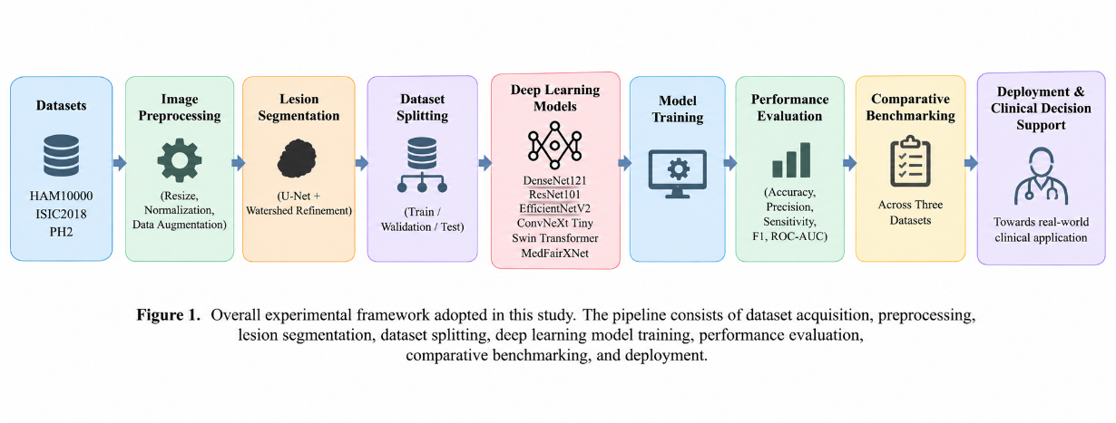 2.2 Datasets
To evaluate the effectiveness and generalization capability of the proposed melanoma detection framework, three publicly available dermoscopic image datasets were utilized in this study: HAM10000, ISIC2018, and PH2. These datasets were selected because they are widely used benchmark datasets in the field of automated skin lesion analysis and provide diverse lesion categories, imaging conditions, and annotation standards. The use of multiple datasets enabled comprehensive evaluation of model robustness and reduced the likelihood of dataset-specific bias.
The datasets differ in terms of image acquisition devices, lesion distributions, class imbalance characteristics, and clinical settings. Consequently, evaluating models across multiple datasets provides a more realistic assessment of their practical applicability in computer-aided dermatological diagnosis.
2.2.1 HAM10000 Dataset
The HAM10000 (Human Against Machine with 10,000 Training Images) dataset is one of the most widely used dermoscopic image repositories for skin lesion analysis. The dataset contains 10,015 dermoscopic images collected from multiple clinical centers, including the Department of Dermatology at the Medical University of Vienna and the skin cancer practice of Cliff Rosendahl in Australia.
The dataset consists of seven diagnostic categories representing common pigmented skin lesions:
- Melanoma (MEL)
- Melanocytic Nevi (NV)
- Basal Cell Carcinoma (BCC)
- Benign Keratosis-like Lesions (BKL)
- Actinic Keratoses and Intraepithelial Carcinoma (AKIEC)
- Dermatofibroma (DF)
- Vascular Lesions (VASC)
The images were captured using dermoscopic imaging systems and subsequently reviewed by dermatology experts. Histopathological examination, follow-up observations, expert consensus, and confocal microscopy were employed as diagnostic confirmation methods.
For the purposes of this study, the original multi-class classification problem was transformed into a binary classification task. Images belonging to the melanoma category were assigned the positive class label, whereas all remaining categories were grouped into the non-melanoma class.
The HAM10000 dataset was primarily utilized for large-scale model training and comparative benchmarking due to its relatively large sample size and diversity of lesion appearances.
Table 1. HAM10000 Dataset Characteristics
Characteristic | Value
Total Images | 10,015
Diagnostic Classes | 7
Image Type | Dermoscopic
Classification Task | Binary
Positive Class | Melanoma
Negative Class | All Other Lesions

2.2.2 ISIC2018 Dataset
The ISIC2018 dataset was released as part of the International Skin Imaging Collaboration (ISIC) Challenge and has become a standard benchmark for skin lesion analysis research. The dataset contains 10,015 dermoscopic images collected from multiple international clinical institutions.
The ISIC initiative aims to improve melanoma diagnosis through the development of publicly accessible image repositories and standardized evaluation protocols. The dataset includes a diverse range of lesion types captured under varying imaging conditions, thereby providing a realistic representation of clinical practice.
The seven lesion categories available in the dataset include:
- Melanoma (MEL)
- Melanocytic Nevus (NV)
- Basal Cell Carcinoma (BCC)
- Actinic Keratosis (AKIEC)
- Benign Keratosis (BKL)
- Dermatofibroma (DF)
- Vascular Lesions (VASC)
Similar to the HAM10000 dataset, the ISIC2018 dataset was converted into a binary classification problem. Melanoma images were assigned label 1, while all non-melanoma categories were assigned label 0.
The dataset was particularly valuable for evaluating model generalization because it contains images acquired from multiple institutions and imaging systems. Such variability introduces domain diversity and makes the dataset suitable for assessing model robustness.
Table 2. ISIC2018 Dataset Characteristics
Characteristic | Value
Total Images | 10,015
Diagnostic Classes | 7
Image Type | Dermoscopic
Classification Task | Binary
Positive Class | Melanoma
Negative Class | All Other Lesions

2.2.3 PH2 Dataset
The PH2 dataset is a smaller but highly curated dermoscopic image dataset developed by the Dermatology Service of Hospital Pedro Hispano in collaboration with the Institute of Telecommunications, Portugal. Unlike HAM10000 and ISIC2018, the PH2 dataset was acquired under controlled imaging conditions using standardized dermoscopic equipment.
The dataset contains a total of 200 dermoscopic images categorized into three diagnostic groups:
- Common Nevi
- Atypical Nevi
- Melanoma
All images were manually reviewed and annotated by dermatology specialists, providing high-quality diagnostic labels. The controlled acquisition process minimizes imaging variability and makes PH2 particularly suitable for evaluating model performance under standardized conditions.
For binary classification, melanoma images were assigned the positive class label, while common nevi and atypical nevi were combined into the non-melanoma category.
Although PH2 is substantially smaller than HAM10000 and ISIC2018, it serves as an important external validation dataset. Strong performance on PH2 indicates that the trained models can generalize beyond the larger training datasets and maintain diagnostic effectiveness in independent clinical settings.
Table 3. PH2 Dataset Characteristics
Lesion Type | Number of Images
Common Nevi | 80
Atypical Nevi | 80
Melanoma | 40
Total | 200

Comparative Dataset Analysis
The three datasets collectively provide a comprehensive benchmark for melanoma detection. HAM10000 offers large-scale diversity, ISIC2018 provides international multi-center variability, and PH2 serves as an external validation dataset with controlled acquisition conditions. By combining these datasets, the present study evaluates model performance across different clinical scenarios and imaging environments.
Table 4. Summary of Datasets Used in This Study
Dataset | Images | Classes | Purpose
HAM10000 | 10,015 | 7 | Benchmark Training and Evaluation
ISIC2018 | 10,015 | 7 | Independent Benchmark Evaluation
PH2 | 200 | 3 | External Validation

Figure 2. Representative dermoscopic images from the HAM10000, ISIC2018, and PH2 datasets, illustrating examples of melanoma and non-melanoma lesions.
(a) Melanoma (HAM10000) | (b) Melanoma (ISIC2018) | (c) Melanoma (PH2)
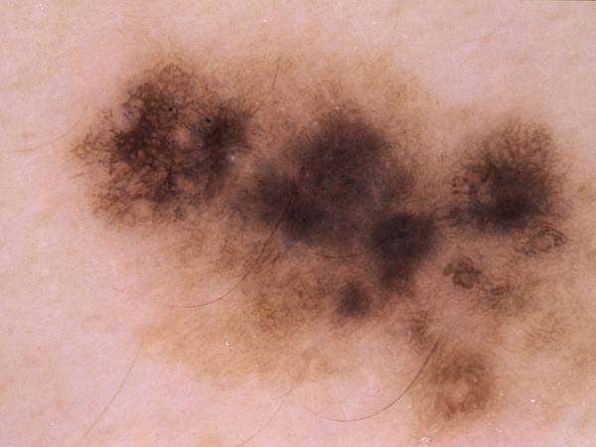 | 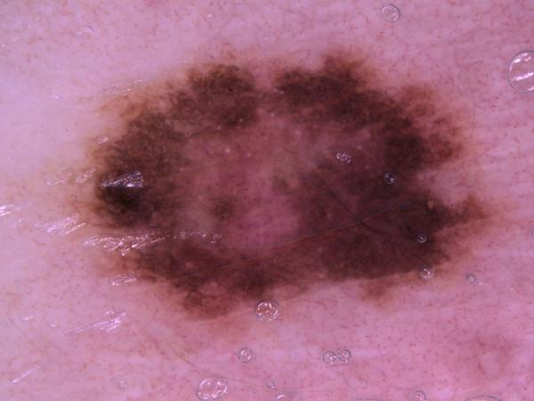 | 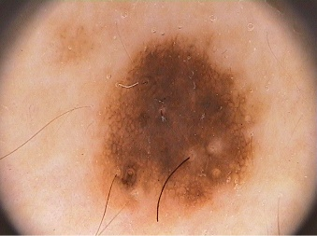
(d) Benign (HAM10000) | (e) Benign (ISIC2018) | (f) Benign (PH2)
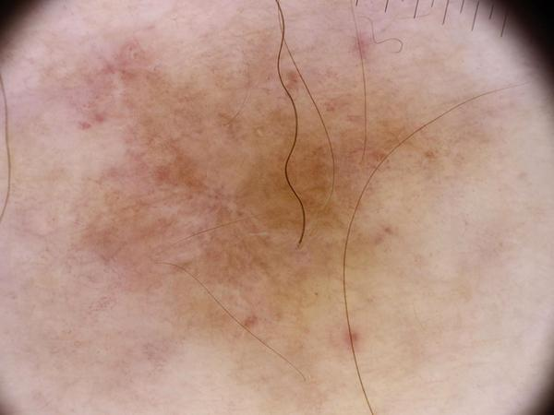 |  | 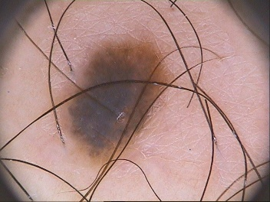
2.3 Data Preparation and Splitting
The raw dermoscopic image datasets were subjected to a comprehensive data preparation pipeline prior to model development. Since the three datasets used in this study (HAM10000, ISIC2018, and PH2) were collected from different clinical environments and originally designed for multi-class lesion classification, a standardized data preparation strategy was required to ensure consistency across experiments. The primary objectives of this stage were to establish a unified binary classification framework, preserve diagnostic information, minimize dataset bias, and facilitate reproducible model training.
2.3.1 Data Cleaning and Quality Verification
Initially, all dataset records were inspected to identify potential inconsistencies, duplicate entries, corrupted images, and missing annotations. Image identifiers were cross-checked against the corresponding metadata files to ensure correct label assignment. Images with valid diagnostic annotations were retained for subsequent analysis.
The integrity of image files was verified prior to preprocessing to avoid training interruptions caused by unreadable or incomplete image data. All images were stored in JPEG format and organized according to their respective datasets.
Following quality verification, image metadata and diagnostic labels were consolidated into structured CSV files to facilitate automated data loading using the PyTorch framework.
2.3.2 Binary Label Harmonization
The original datasets contained multiple diagnostic categories representing different skin lesion types. However, the objective of the present study was melanoma detection; therefore, all datasets were transformed into a unified binary classification problem.
A binary labeling strategy was adopted in which:
$$Melanoma=1 \\ Non\text{-}Melanoma=0$$
For the HAM10000 dataset, lesions belonging to the melanoma (MEL) category were assigned the positive class label. The remaining diagnostic categories, including melanocytic nevi, basal cell carcinoma, benign keratosis-like lesions, dermatofibroma, vascular lesions, and actinic keratoses, were grouped into the non-melanoma category.
A similar procedure was applied to the ISIC2018 dataset, where melanoma lesions were assigned label 1 and all other lesion categories were assigned label 0.
For the PH2 dataset, images diagnosed as melanoma were assigned the positive class label, whereas common nevi and atypical nevi were combined into a single non-melanoma category. This harmonization strategy enabled direct comparison of model performance across multiple datasets despite differences in their original diagnostic taxonomies.
Table 5. Binary Label Mapping Strategy
Original Diagnosis | Binary Class
Melanoma (MEL) | 1
Melanocytic Nevus (NV) | 0
Basal Cell Carcinoma (BCC) | 0
Benign Keratosis (BKL) | 0
Actinic Keratosis (AKIEC) | 0
Dermatofibroma (DF) | 0
Vascular Lesion (VASC) | 0
Common Nevus (PH2) | 0
Atypical Nevus (PH2) | 0

2.3.3 Dataset Partitioning Strategy
To obtain reliable estimates of model generalization performance, the datasets were partitioned into independent training, validation, and testing subsets.
The training subset was used for parameter optimization and model learning. The validation subset was employed for monitoring model behavior during training and detecting potential overfitting. The testing subset remained completely isolated throughout model development and was used exclusively for final performance evaluation.
A stratified sampling strategy was adopted to preserve the original class distribution within each subset. This approach is particularly important in melanoma detection because melanoma cases represent a minority class relative to benign lesions. Maintaining similar class proportions across all subsets helps prevent sampling bias and improves the reliability of performance comparisons.
For the ISIC2018 dataset, the final partitioning scheme consisted of approximately 70% training data, 15% validation data, and 15% testing data.

Table 6. ISIC2018 Dataset Partitioning
Dataset Split | Number of Images
Training | 7010
Validation | 1502
Testing | 1503
Total | 10015

2.3.4 Class Distribution Analysis
Class imbalance is a common challenge in melanoma detection because malignant lesions occur less frequently than benign lesions. Consequently, a detailed analysis of class distribution was performed after dataset partitioning.
The stratified splitting strategy successfully preserved the original melanoma-to-non-melanoma ratio across all subsets. Table 7 summarizes the resulting class distributions for the ISIC2018 dataset.
Table 7. Class Distribution After Stratified Splitting
Subset | Non-Melanoma | Melanoma
Training | 6231 | 779
Validation | 1335 | 167
Testing | 1336 | 167
The distribution indicates that melanoma lesions constitute approximately 11% of the dataset, reflecting the inherent class imbalance present in real-world clinical screening scenarios. Such imbalance increases the difficulty of the classification task and necessitates evaluation using sensitivity, F1-score, and ROC-AUC in addition to overall accuracy.
2.3.5 Reproducibility Considerations
To ensure experimental reproducibility, all dataset partitioning procedures were performed using a fixed random seed. The use of deterministic splitting guarantees that the same train-validation-test subsets can be regenerated in future experiments and independently verified by other researchers.
The random seed used throughout this study was:
$$Random Seed=42$$
Furthermore, identical dataset partitions were maintained across all benchmark architectures and the proposed MedFairXNet framework. This ensured that observed performance differences resulted from architectural characteristics rather than variations in data allocation.
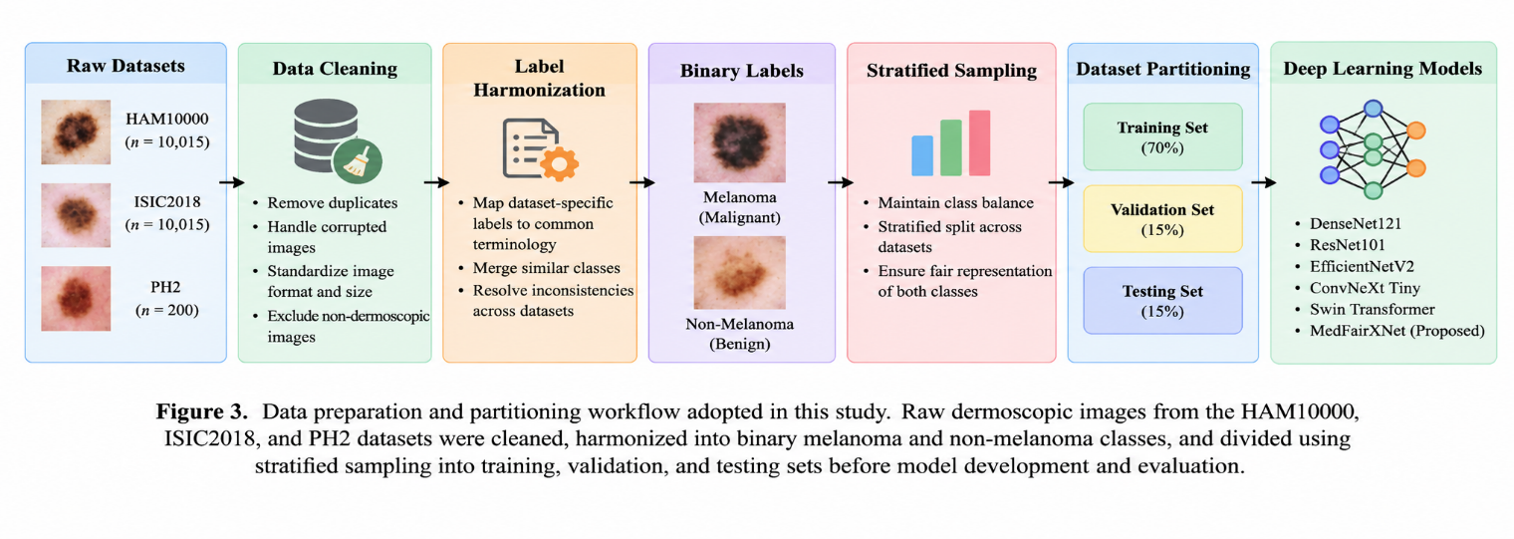2.4 Image Preprocessing
The quality and consistency of input images play a critical role in the performance of deep learning-based medical image analysis systems. Dermoscopic images acquired from different clinical institutions often exhibit significant variations in illumination conditions, image resolution, acquisition devices, skin tone characteristics, lesion size, color distribution, and the presence of imaging artifacts. Such variability may adversely affect feature extraction and reduce the generalization capability of deep learning models.
To address these challenges, a comprehensive preprocessing pipeline was implemented prior to model training. The objective of the preprocessing stage was to improve image quality, enhance diagnostically relevant lesion characteristics, suppress non-informative artifacts, standardize image representations across datasets, and generate high-quality inputs suitable for deep neural network architectures.
The preprocessing framework consisted of multiple sequential stages, including image standardization, artifact removal, contrast enhancement, color normalization, image resizing, intensity normalization, and data augmentation. Each preprocessing step was designed to improve the robustness and reliability of subsequent melanoma classification.
2.4.1 Image Standardization
The dermoscopic images included in HAM10000, ISIC2018, and PH2 were acquired using different imaging systems and clinical protocols. Consequently, the images exhibited variations in resolution, aspect ratio, color distribution, and image encoding formats.
To establish a uniform representation, all images were first converted into the RGB color space. RGB conversion ensured compatibility with the pretrained convolutional and transformer-based architectures employed in this study. Furthermore, image integrity checks were performed to identify corrupted or unreadable files before further processing.
Following color space conversion, all images were standardized into a consistent format suitable for automated preprocessing and model training. Standardization reduced dataset heterogeneity and improved reproducibility across experiments.
2.4.2 Hair Artifact Removal
One of the most common artifacts observed in dermoscopic images is the presence of hair structures partially covering the lesion surface. Hair artifacts can obscure important visual characteristics such as lesion borders, pigmentation patterns, asymmetry, and texture. If not removed, these structures may introduce noise into the learning process and negatively affect classification performance.
To minimize this issue, a hair removal procedure was incorporated into the preprocessing pipeline. Hair structures were identified based on their elongated morphology and relatively darker intensity compared to surrounding skin regions. Once detected, the affected pixels were reconstructed using image inpainting techniques that estimate missing information from neighboring pixels.
The resulting images exhibited clearer lesion boundaries and improved visibility of clinically significant features. This preprocessing step was particularly important for enhancing lesion segmentation and improving the quality of features extracted by deep neural networks.
Figure 5. Representative examples demonstrating the effect of hair artifact removal on dermoscopic images.
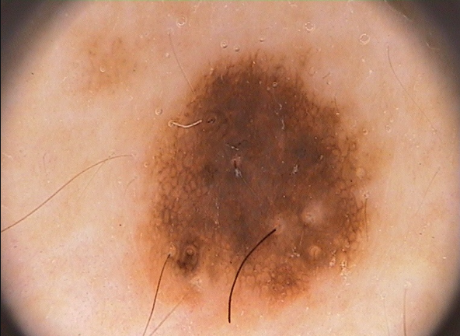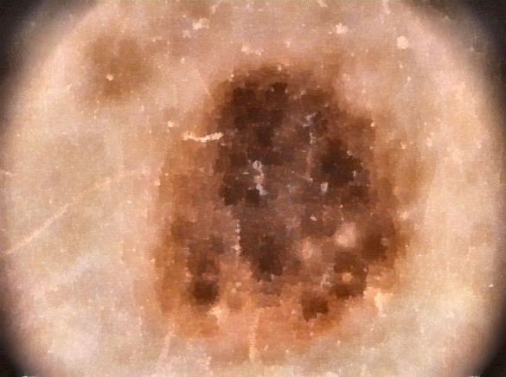
(a) Original dermoscopic image (b) Preprocessed image
2.4.3 Contrast Enhancement Using CLAHE
The visual appearance of dermoscopic lesions is strongly influenced by illumination conditions and image contrast. In many cases, subtle lesion structures and pigmentation patterns may not be clearly visible in the original image. Poor contrast can limit the ability of deep learning models to identify clinically relevant melanoma characteristics.
To improve local image contrast, Contrast Limited Adaptive Histogram Equalization (CLAHE) was applied. CLAHE is an advanced contrast enhancement technique that operates on small image regions rather than the entire image. Unlike traditional histogram equalization methods, CLAHE restricts excessive amplification of noise by applying a clipping limit to the local histogram.
The application of CLAHE significantly improved the visibility of lesion borders, pigment networks, color variations, and structural irregularities. Enhanced local contrast facilitated more effective feature extraction and improved lesion representation within the learned feature space.
The enhanced images retained diagnostically important information while reducing the influence of uneven illumination and low-contrast regions.
Figure 6. CLAHE-enhanced image
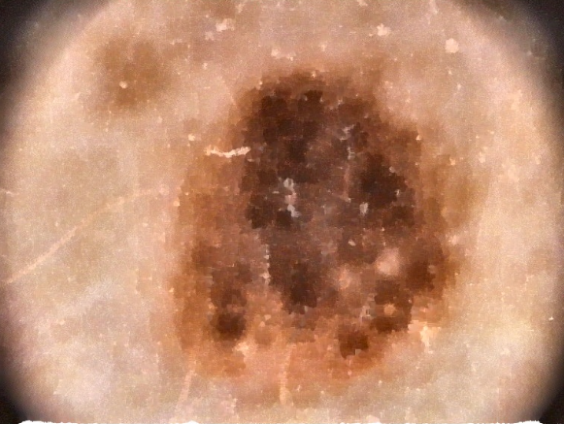
2.4.4 Color Normalization
Color characteristics represent one of the primary sources of variability among dermoscopic image datasets. Differences in camera sensors, lighting environments, acquisition settings, and skin pigmentation can substantially alter lesion appearance even when the underlying pathology remains unchanged.
Such variability can lead to domain shift, whereby models trained on one dataset experience performance degradation when evaluated on another dataset.
To mitigate this problem, color normalization was applied to standardize color distributions across images. The normalization procedure aimed to reduce inter-dataset color discrepancies while preserving diagnostically relevant lesion information.
Color normalization improves the consistency of visual features presented to the learning algorithm and facilitates more reliable transfer of learned representations across datasets.
The standardization of color information is particularly important when evaluating models across independent datasets such as HAM10000, ISIC2018, and PH2.
2.4.5 Image Resizing and Spatial Standardization
Deep learning architectures require fixed-size image inputs for efficient batch processing and parameter optimization. Since the original datasets contained images with varying spatial dimensions, all images were resized to a common resolution before training. The final input resolution adopted throughout the study was:
$$224×224×3$$
This resolution was selected because it provides a suitable balance between computational efficiency and preservation of lesion morphology. Furthermore, it is compatible with the input requirements of EfficientNetV2-S, DenseNet121, ResNet101, ConvNeXt Tiny, Swin Transformer, and the proposed MedFairXNet architecture.
Spatial standardization ensured that all models received uniform input dimensions, thereby enabling fair performance comparison across architectures.
2.4.6 Pixel Intensity Normalization
Pixel intensity normalization was performed to improve numerical stability during training and accelerate convergence of the optimization process.
All images were normalized using the ImageNet mean and standard deviation values:
$$Mean=\left[0.485 , 0.456 , 0.406\right] \\ Standard Deviation=\left[0.229 , 0.224 , 0.225\right]$$
These values correspond to the normalization scheme used during pretraining of the benchmark architectures on the ImageNet dataset.
Matching the original ImageNet normalization procedure ensures compatibility with pretrained feature representations and improves transfer learning performance.
Normalization also reduces internal covariate shift and facilitates stable gradient propagation throughout the network.
2.4.7 Data Augmentation
Although large public datasets were utilized, melanoma samples remained significantly underrepresented relative to benign lesions. Such class imbalance increases the risk of model overfitting and reduces the ability of the network to generalize to unseen data. To address these challenges, data augmentation techniques were applied exclusively to the training set. Data augmentation artificially increases dataset diversity by generating modified versions of existing images while preserving diagnostic content.
The augmentation pipeline included:
Random Horizontal Flip
Images were randomly flipped horizontally to improve orientation invariance and reduce sensitivity to lesion positioning.
Random Vertical Flip
Vertical flipping introduced additional spatial variability and encouraged the model to learn orientation-independent lesion characteristics.
Random Rotation
Random rotational transformations were applied to simulate variations in image acquisition angles commonly encountered in clinical practice.
Random Resized Crop
Random cropping and rescaling operations enabled the network to focus on different lesion regions and improved robustness against positional variations.
The combination of these augmentation strategies exposed the models to a broader range of image appearances, thereby improving generalization and reducing overfitting.
Figure 7. Examples of augmented dermoscopic images generated using flipping, rotation, and cropping operations.
(a) Original | (b) Horizontal Flip
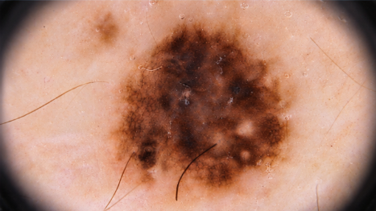 | 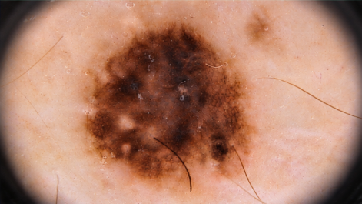

(c) Rotation (15°–30°) | (d) Random Crop/Zoom
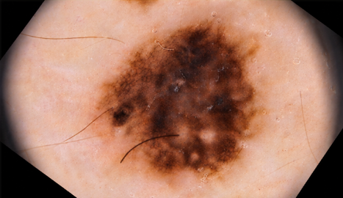 | 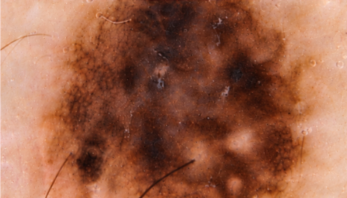
2.4.8 Overall Preprocessing Pipeline
The complete preprocessing framework adopted in this study is illustrated in Figure 8. The proposed pipeline sequentially transformed raw dermoscopic images through artifact reduction, contrast enhancement using CLAHE, color normalization, and image standardization, thereby generating high-quality inputs suitable for subsequent segmentation and deep learning–based melanoma classification.
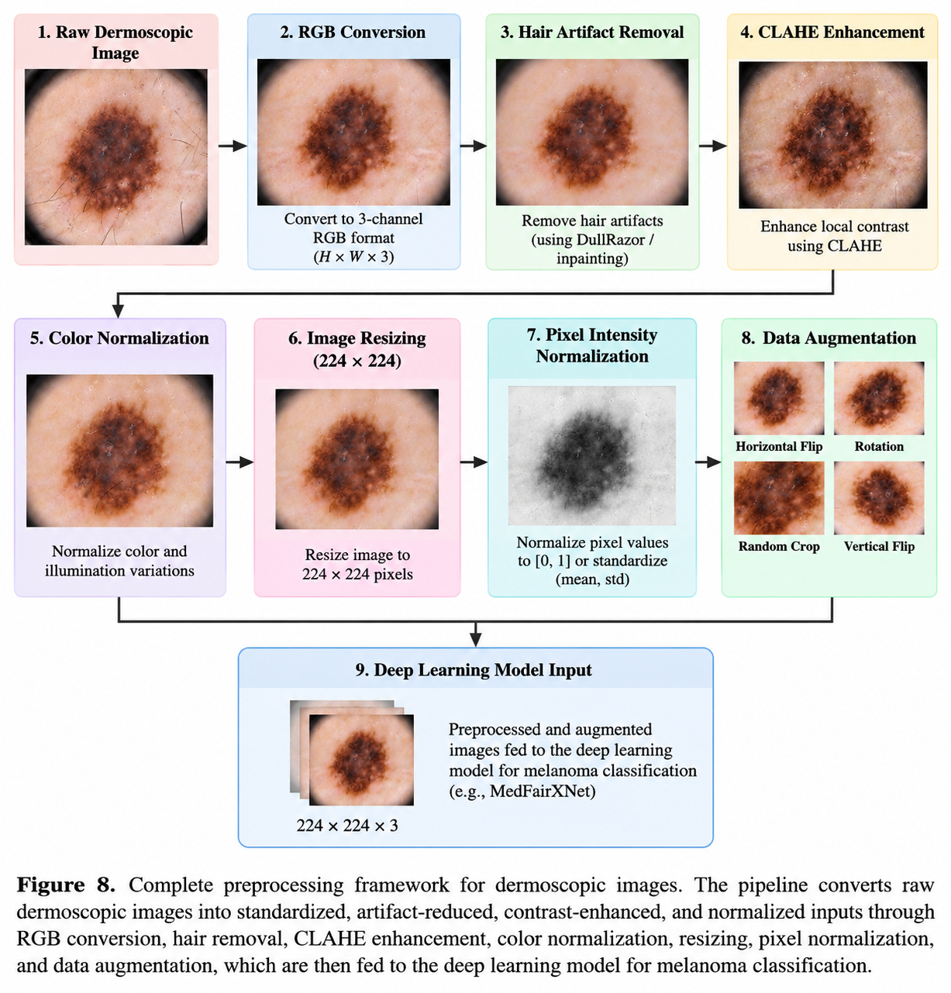
Table 8. Summary of Preprocessing Operations
Preprocessing Step | Objective
RGB Conversion | Standardized color representation
Hair Removal | Artifact reduction
CLAHE Enhancement | Improved local contrast
Color Normalization | Reduced color variability
Image Resizing | Fixed input dimensions
Intensity Normalization | Stable optimization
Data Augmentation | Improved generalization

2.5 Lesion Segmentation
Accurate lesion segmentation is a critical step in automated melanoma detection systems. The objective of segmentation is to isolate the lesion region from the surrounding healthy skin and background structures. By focusing the analysis on the lesion itself, segmentation reduces the influence of irrelevant image content and enables deep learning models to learn more discriminative lesion-specific features.
Dermoscopic images often contain artifacts such as hairs, ruler markings, air bubbles, color charts, and surrounding healthy skin regions. These factors may introduce noise into the classification process and reduce model performance. Therefore, lesion segmentation was incorporated into the proposed framework as a preprocessing stage to improve lesion localization and enhance feature extraction. The segmentation pipeline consisted of two complementary approaches:
- U-Net-based deep learning segmentation
- Watershed-based morphological segmentation
The combination of deep learning and traditional image processing techniques provided robust lesion boundary extraction across different datasets and imaging conditions.
2.5.1 Importance of Lesion Segmentation
In dermoscopic image analysis, the lesion usually occupies only a portion of the entire image. Large regions of normal skin contribute little diagnostic information and may distract the learning process.
Segmentation offers several advantages:
- Improved lesion localization
- Reduction of background noise
- Better boundary representation
- Enhanced extraction of lesion morphology
- Improved classification performance
- Increased model interpretability
Furthermore, segmentation facilitates analysis of clinically significant melanoma characteristics such as:
- Asymmetry
- Border irregularity
- Color variation
- Diameter
- Structural heterogeneity
These characteristics are closely associated with the ABCDE diagnostic rule commonly used by dermatologists.
2.5.2 U-Net-Based Lesion Segmentation
To automatically identify lesion boundaries, a U-Net architecture was employed.
U-Net is one of the most widely used deep learning architectures for biomedical image segmentation due to its ability to capture both local and global image context. Originally proposed for medical image analysis, U-Net has demonstrated strong performance in various segmentation tasks including skin lesion delineation.
The architecture follows an encoder-decoder design.
Encoder Path
The encoder progressively extracts hierarchical feature representations while reducing spatial dimensions through convolution and pooling operations.
The encoder captures:
- Texture information
- Color patterns
- Pigment networks
- Border structures
- Global lesion context
Decoder Path
The decoder reconstructs spatial information and generates a pixel-level segmentation mask.
Upsampling operations combined with skip connections enable accurate localization of lesion boundaries.
Skip Connections
A key component of U-Net is the use of skip connections between encoder and decoder layers.
These connections:
- Preserve fine-grained spatial information
- Improve boundary delineation
- Reduce information loss
- Facilitate gradient propagation
The final output is a binary segmentation mask in which lesion pixels are assigned a value of 1 and background pixels are assigned a value of 0.
2.5.3 U-Net Architecture
The U-Net architecture implemented in this study consisted of:
Contracting Path
Input Image
↓
Conv Block
↓
Max Pooling
↓
Conv Block
↓
Max Pooling
↓
Conv Block
↓
Bottleneck Layer
Expanding Path
Bottleneck
↓
Up Convolution
↓
Skip Connection
↓
Conv Block
↓
Up Convolution
↓
Skip Connection
↓
Output Segmentation Mask
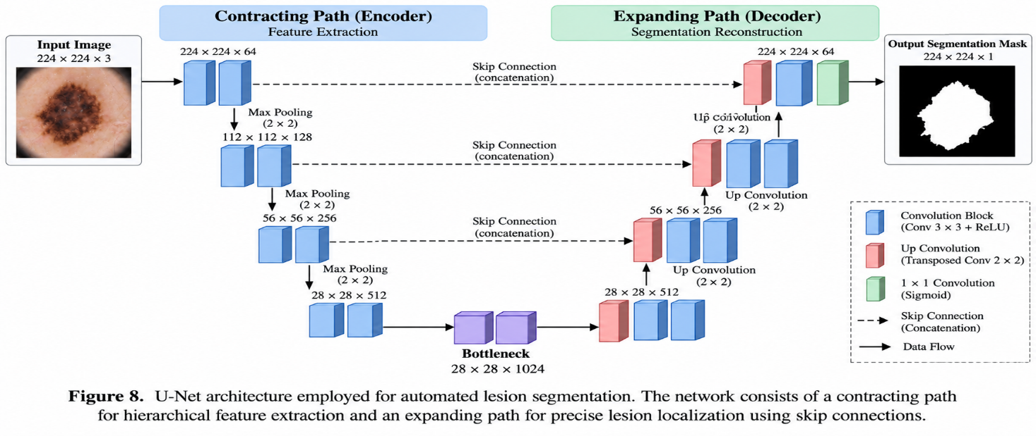

2.5.4 Watershed-Based Segmentation
In addition to deep learning segmentation, a watershed segmentation algorithm was implemented as a complementary image processing approach.
Watershed segmentation is a region-based segmentation technique inspired by topographical analysis. The image is interpreted as a three-dimensional landscape where pixel intensities represent elevation values.
The algorithm identifies catchment basins and watershed lines to separate different image regions.
The watershed procedure consisted of:
Step 1: Image Grayscale Conversion
The RGB image was converted to grayscale.
Step 2: Thresholding
Binary thresholding was applied to distinguish foreground lesion regions from the background.
Step 3: Morphological Operations
Morphological opening and closing operations were performed to remove noise and refine lesion boundaries.
Step 4: Distance Transform
Distance transformation was applied to identify lesion centers.
Step 5: Marker Generation
Foreground and background markers were generated.
Step 6: Watershed Transformation
The watershed algorithm was applied to obtain the final lesion boundaries.
This approach provided an interpretable segmentation baseline and was particularly useful for images with clearly distinguishable lesion borders.
2.5.5 Segmentation Mask Generation
For each dermoscopic image, a binary lesion mask was generated.
The segmentation masks were subsequently used to:
- Visualize lesion boundaries
- Verify lesion localization
- Improve preprocessing quality
- Support explainability analysis
Table 9. Mask Contained
Pixel Value | Meaning
0 | Background
1 | Lesion Region

2.5.6 Segmentation Workflow
The complete segmentation workflow is illustrated below.
Dermoscopic Image
↓
Hair Removal
↓
CLAHE Enhancement
↓
U-Net Segmentation
↓
Binary Lesion Mask
↓
Boundary Refinement
↓
Segmented Lesion
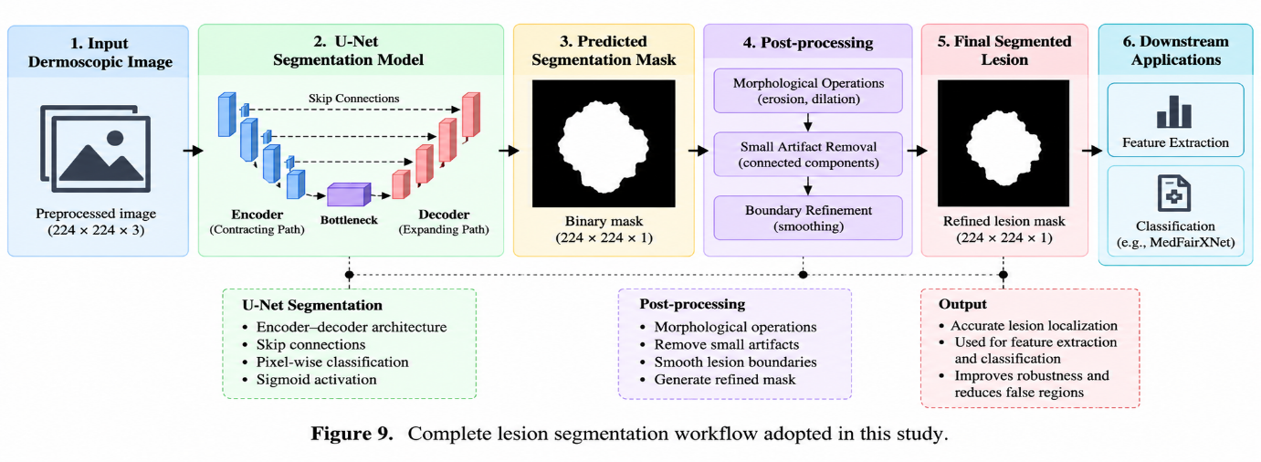
2.5.7 Segmentation Performance Assessment
The quality of segmentation was visually assessed by comparing generated masks against lesion boundaries observed in dermoscopic images.
Representative segmentation examples were analyzed to verify:
- Boundary accuracy
- Lesion coverage
- Shape preservation
- Artifact suppression
The resulting segmentation masks successfully isolated lesion regions and improved lesion visibility for subsequent classification tasks.
2.5.8 Role of Segmentation in the Proposed Framework
Lesion segmentation served as an intermediate preprocessing stage within the overall melanoma detection pipeline. By reducing background interference and emphasizing diagnostically relevant lesion structures, segmentation improved the quality of input data presented to the deep learning classifiers.
The segmented lesion images were subsequently used for training and evaluating EfficientNetV2-S, DenseNet121, ResNet101, ConvNeXt Tiny, Swin Transformer, and the proposed MedFairXNet architecture.
Figure 10. Representative lesion segmentation results demonstrating successful lesion boundary extraction.
Original Image | Ground Truth Mask | Predicted Mask
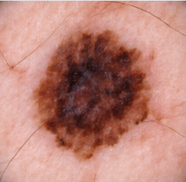
2.6 Benchmark Models
To establish a comprehensive performance baseline, multiple state-of-the-art deep learning architectures were selected and evaluated. These benchmark models represent different generations of computer vision architectures, including conventional convolutional neural networks, modern CNN architectures, and transformer-based vision models.
The selected models were chosen based on their demonstrated effectiveness in medical image analysis and image classification tasks. Evaluating diverse architectures enables a rigorous comparison of feature extraction capabilities, classification performance, computational efficiency, and generalization behavior across multiple datasets.
The benchmark architectures investigated in this study include:
- EfficientNetV2-S
- DenseNet121
- ResNet101
- ConvNeXt Tiny
- Swin Transformer
All models were initialized using ImageNet-pretrained weights and fine-tuned for binary melanoma classification.
2.6.1 EfficientNetV2-S
EfficientNetV2-S is a modern convolutional neural network architecture designed to achieve high classification performance while maintaining computational efficiency.
Unlike traditional CNNs that simply increase network depth or width, EfficientNetV2 employs compound scaling to simultaneously optimize:
- Network depth
- Network width
- Input resolution
This balanced scaling strategy improves both training speed and classification accuracy.
The architecture utilizes:
- Fused-MBConv blocks
- Mobile Inverted Bottleneck Convolutions
- Squeeze-and-Excitation modules
These components improve feature extraction while reducing computational cost.
For melanoma detection, EfficientNetV2 is particularly advantageous because skin lesion images contain subtle texture variations and color patterns that require efficient multi-scale feature learning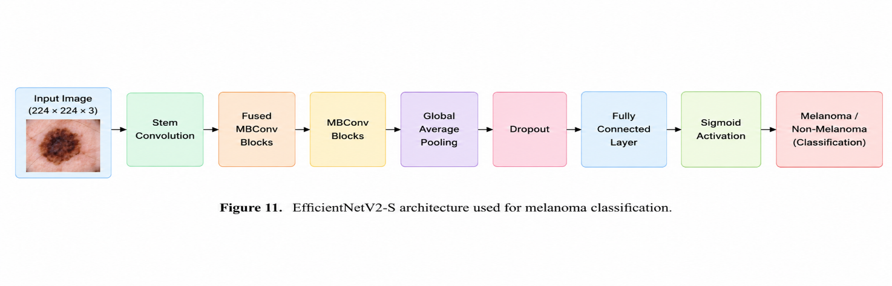2.6.2 DenseNet121
DenseNet121 belongs to the Dense Convolutional Network family and addresses the vanishing gradient problem through dense connectivity.
In DenseNet, each layer receives feature maps from all preceding layers.
Mathematically:
$$x_{l}=H_{l}\left(\left[x_{0} , x_{1} , x_{2} , … , x_{l-1}\right]\right)$$
where:
- $x_{l}$denotes the current layer output
- $H_{l}$represents convolutional transformations
This dense feature reuse offers several advantages:
- Improved information flow
- Better gradient propagation
- Reduced parameter count
- Enhanced feature reuse
DenseNet is highly effective in medical imaging applications because diagnostically relevant features often appear at multiple scales and locations.
The architecture consists of:
- Dense Blocks
- Transition Layers
- Global Average Pooling
- Fully Connected Classification Layer
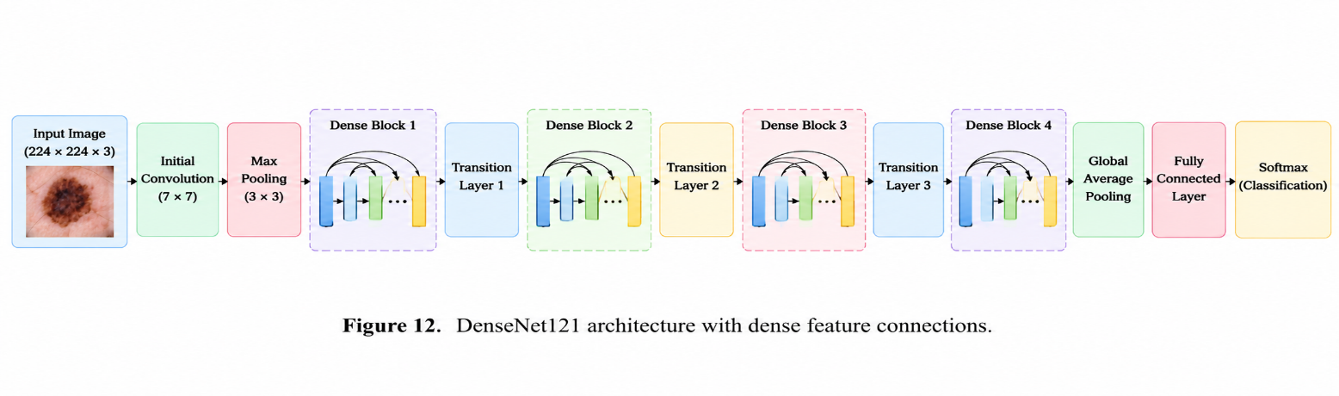2.6.3 ResNet101
ResNet101 is a deep residual learning architecture developed to overcome degradation problems associated with very deep neural networks.
Traditional deep CNNs often experience training difficulties as depth increases. ResNet addresses this issue through residual learning.
Instead of learning:
$$H\left(x\right)$$
the network learns:
$$F\left(x\right)=H\left(x\right)-x$$
and computes:
$$H\left(x\right)=F\left(x\right)+x$$
using shortcut connections.
Residual learning offers:
- Improved optimization
- Better gradient propagation
- Faster convergence
- Increased representational capacity
The ResNet101 architecture contains:
- 101 layers
- Residual Blocks
- Batch Normalization
- Global Average Pooling
Because melanoma detection requires extraction of complex hierarchical visual features, deep residual learning provides an effective classification framework.
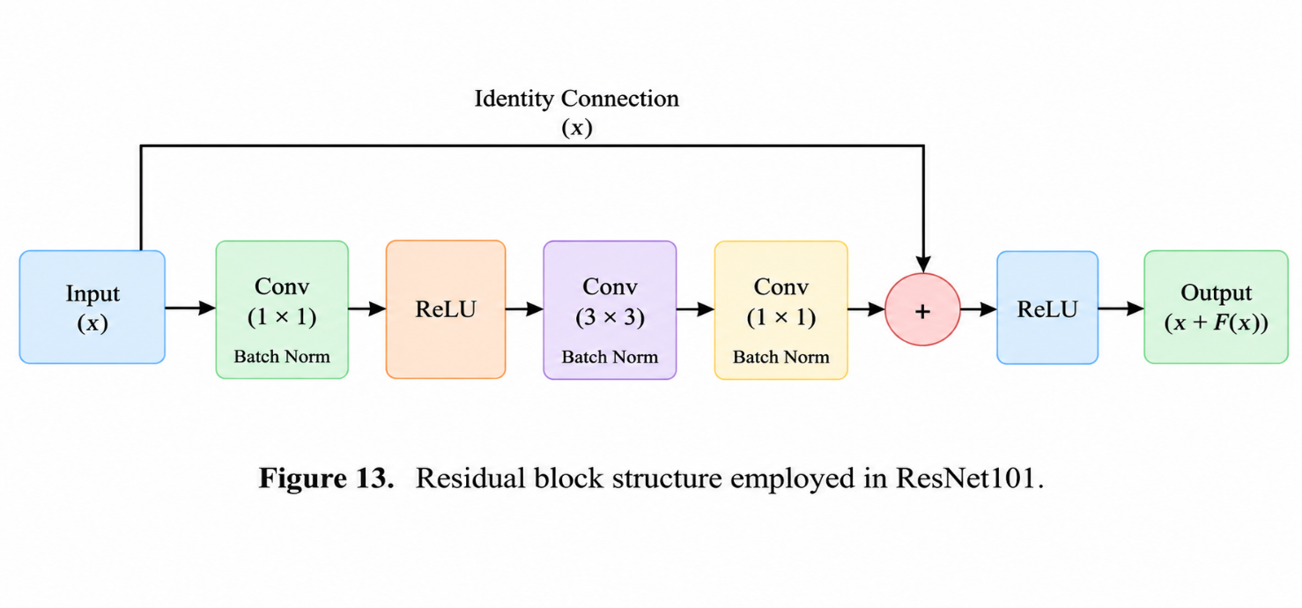2.6.4 ConvNeXt Tiny
ConvNeXt Tiny is a modern convolutional architecture inspired by design principles introduced in Vision Transformers.Although ConvNeXt remains fundamentally CNN-based, several architectural modifications improve performance significantly.
Key design elements include:
- Large kernel convolutions
- Layer normalization
- Inverted bottleneck blocks
- Reduced activation frequency
- Modern training strategies
These modifications enable ConvNeXt to achieve transformer-like performance while preserving convolutional inductive biases.
For dermoscopic image analysis, ConvNeXt effectively captures:
- Lesion texture
- Border irregularity
- Pigmentation patterns
- Structural heterogeneity
The model provides a strong CNN baseline against transformer-based architectures.
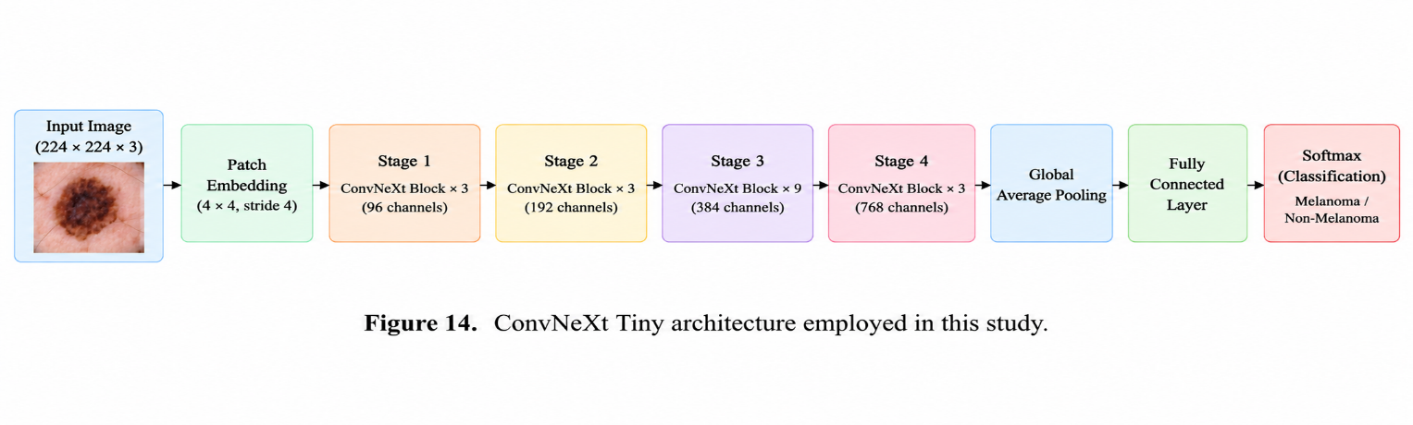2.6.5 Swin Transformer
Swin Transformer is a hierarchical Vision Transformer architecture specifically designed for image analysis.Unlike conventional Vision Transformers that apply global self-attention across the entire image, Swin Transformer introduces:
Window-Based Self-Attention
Self-attention is computed within local windows, reducing computational complexity.
Shifted Window Mechanism
Windows are shifted between layers to facilitate information exchange across neighboring regions.
This strategy enables:
- Efficient computation
- Multi-scale representation learning
- Enhanced contextual understanding
The architecture consists of:
- Patch Partitioning
- Linear Embedding
- Swin Transformer Blocks
- Patch Merging Layers
- Classification Head
For melanoma detection, Swin Transformer can effectively model long-range relationships among lesion structures and pigmentation patterns.
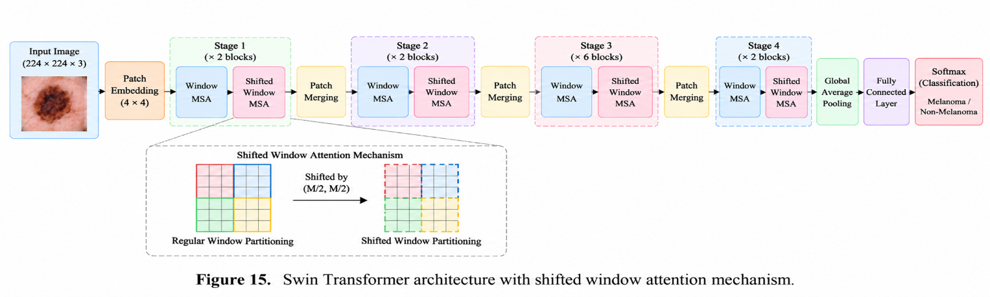
2.6.6 Comparative Characteristics of Benchmark Models
Table 10. Benchmark Architecture Comparison
Model | Architecture Type | Key Strength
EfficientNetV2-S | CNN | Efficient scaling
DenseNet121 | CNN | Feature reuse
ResNet101 | CNN | Residual learning
ConvNeXt Tiny | Modern CNN | Transformer-inspired design
Swin Transformer | Vision Transformer | Long-range attention

2.6.7 Benchmarking Strategy
All benchmark architectures were trained under identical experimental conditions to ensure fair comparison. The same preprocessing pipeline, train-validation-test partitions, optimization settings, evaluation metrics, and hardware environment were used throughout the experiments.Each model was independently evaluated on HAM10000, ISIC2018, and PH2 datasets. Performance comparisons were conducted using Accuracy, Precision, Sensitivity, F1-Score, and ROC-AUC metrics.
The benchmark results provide a comprehensive reference against which the proposed MedFairXNet architecture is evaluated.
2.7 Proposed MedFairXNet Architecture
The primary objective of this study was not only to benchmark existing deep learning architectures for melanoma detection but also to investigate a unified framework capable of learning robust lesion representations while maintaining generalization across multiple datasets. To achieve this objective, a customized architecture referred to as MedFairXNet was developed and evaluated.
MedFairXNet was designed to combine efficient feature extraction, multi-scale representation learning, and robust classification within a single end-to-end framework. The architecture aims to address common challenges encountered in melanoma classification, including lesion appearance variability, class imbalance, inter-dataset domain shift, and subtle visual differences between malignant and benign lesions.
Unlike conventional convolutional neural networks that primarily focus on local feature extraction, MedFairXNet integrates hierarchical feature learning and global contextual understanding to improve diagnostic performance.
The overall architecture consists of four major components:
- Input Processing Module
- Deep Feature Extraction Module
- Multi-Scale Feature Aggregation Module
- Classification Head
2.7.1 Architectural Overview
The proposed MedFairXNet framework receives a preprocessed dermoscopic image as input and progressively transforms the image into a high-level feature representation suitable for melanoma classification.
Figure 16: The overall processing pipeline is illustrated below:
Input Dermoscopic Image
↓
Preprocessing
↓
Feature Extraction Backbone
↓
Multi-Scale Feature Aggregation
↓
Global Feature Representation
↓
Fully Connected Layers
↓
Sigmoid Output
↓
Melanoma / Non-Melanoma
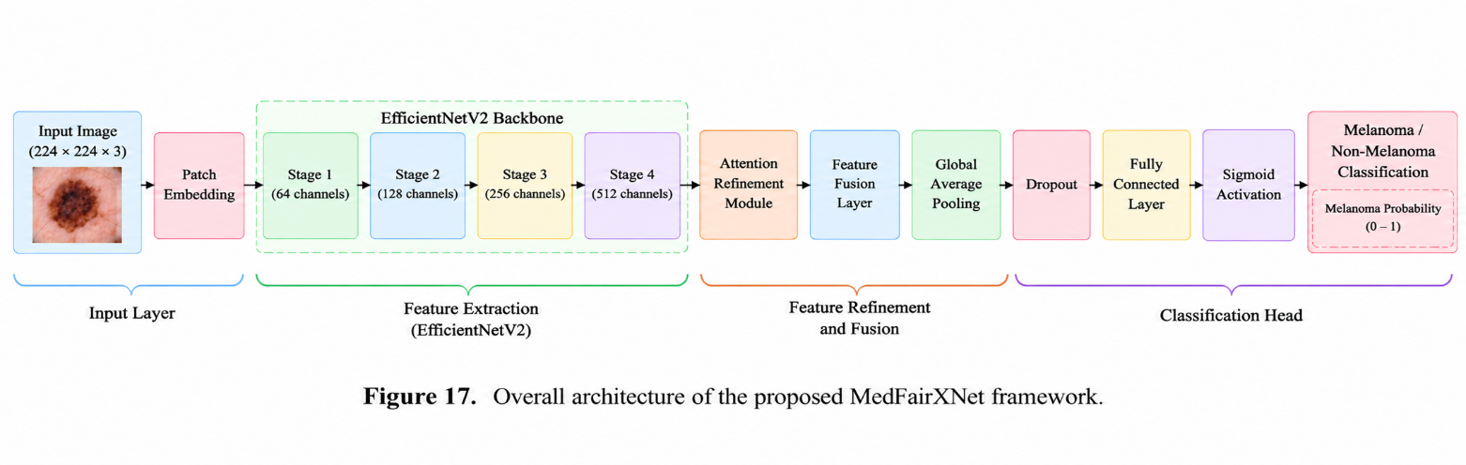2.7.2 Input Layer
The input to the network consists of RGB dermoscopic images resized to:
$$224×224×3$$Prior to entering the network, images undergo:
- Hair artifact removal
- CLAHE enhancement
- Color normalization
- Intensity normalization
These preprocessing operations improve lesion visibility and reduce dataset-specific variability.
2.7.3 Deep Feature Extraction Module
The feature extraction component is responsible for learning discriminative lesion representations from dermoscopic images. The backbone network employs multiple convolutional layers that progressively capture:
- Lesion texture
- Pigmentation patterns
- Border irregularity
- Color heterogeneity
- Structural asymmetry
Each convolutional block consists of:
- Convolution
- Batch Normalization
- Non-linear activation
- Pooling
The convolution operation can be expressed as:
$$F\left(x\right)=W*x+b$$where:
- $x$= input feature map
- $W$= convolution kernel
- $b$= bias term
The resulting feature maps capture increasingly abstract lesion characteristics as network depth increases.
2.7.4 Multi-Scale Feature Learning
Melanoma lesions exhibit diagnostically relevant patterns at multiple spatial scales. Fine-scale features such as pigment networks coexist with larger structures such as asymmetrical borders and irregular lesion shapes. To effectively capture information across different scales, MedFairXNet employs a multi-scale feature aggregation strategy. Features extracted from different network stages are combined to generate a richer lesion representation.
This mechanism enables the model to simultaneously learn:
- Local texture information
- Intermediate lesion structures
- Global lesion morphology
Multi-scale learning improves robustness against lesion size variations and enhances generalization across datasets.
2.7.5 Global Feature Aggregation
Following feature extraction, Global Average Pooling (GAP) is applied. Global Average Pooling reduces the spatial dimensions of feature maps while preserving important semantic information.
For a feature map $F$, GAP is computed as:
$GAP\left(F\right)=\frac{1}{HW}\sum_{i=1}^{H}{\sum_{j=1}^{W}{F}}\left(i , j\right)$ where:
- $H$= feature map height
- $W$= feature map width
The resulting feature vector represents the overall lesion characteristics and serves as input to the classification layer.
2.7.6 Classification Head
The final classification stage consists of fully connected layers followed by a sigmoid activation function. The fully connected layer transforms the extracted feature representation into a melanoma probability score.
The output probability is calculated as:
$$P\left(y=1\right)=σ\left(z\right)$$where:
$σ\left(z\right)=\frac{1}{1+e^{-z}}$ and:
- $P\left(y=1\right)$represents melanoma probability
- $σ$denotes the sigmoid activation function
A threshold of 0.5 is applied to generate the final binary prediction.
If:
$$P\left(y=1\right)>0.5$$the lesion is classified as melanoma. Otherwise, it is classified as non-melanoma.
2.7.7 Regularization Strategy
To improve model generalization and reduce overfitting, regularization techniques were incorporated into the training process. These include:
- Data augmentation
- Batch normalization
- Transfer learning
- Early validation monitoring
The combination of these strategies enhances robustness when training on relatively limited medical image datasets.
2.7.8 Advantages of MedFairXNet
The proposed MedFairXNet architecture offers several advantages for melanoma classification: Efficient Feature Learning
The architecture learns highly discriminative lesion representations while maintaining computational efficiency.
Multi-Scale Representation
The model captures both local and global lesion characteristics.
Improved Generalization
The framework is designed to perform consistently across independent datasets.
Transfer Learning Compatibility
The architecture effectively leverages pretrained visual representations.
Clinical Applicability
The model focuses on diagnostically relevant lesion structures, making it suitable for computer-aided melanoma screening systems.
2.7.9 Integration within the Proposed Framework
MedFairXNet forms the central component of the proposed melanoma detection pipeline. The complete workflow is summarized below:
Dataset Acquisition
↓
Preprocessing
↓
Lesion Segmentation
↓
MedFairXNet
↓
Melanoma Probability
↓
Binary Classification
↓
Performance Evaluation
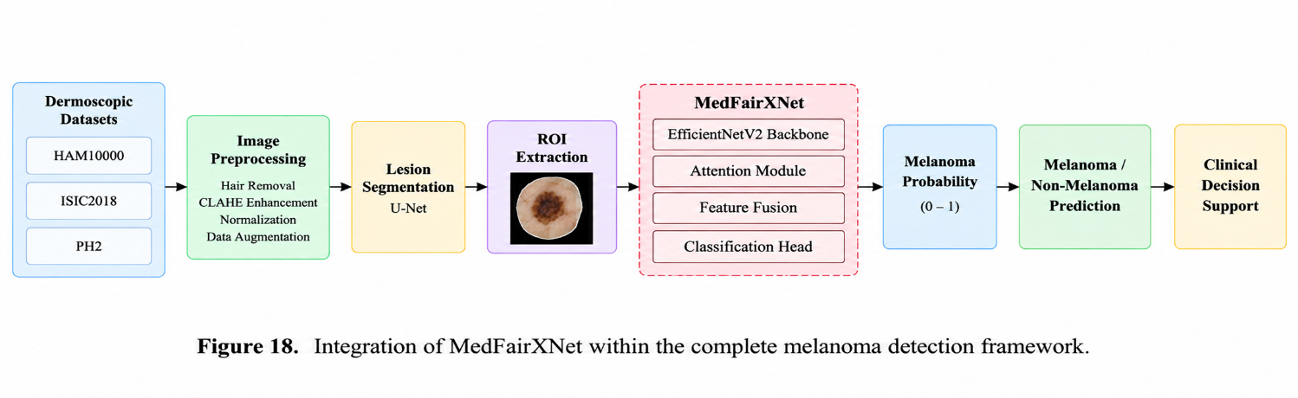2.7.10 Novel Contributions of MedFairXNet
The key contributions of the proposed architecture include:
- A unified framework for melanoma detection across multiple datasets.
- Multi-scale feature extraction for improved lesion representation.
- Robust classification under dataset variability and class imbalance.
- Compatibility with transfer learning and medical image analysis workflows.
- Comprehensive evaluation against both CNN-based and transformer-based benchmark models.
2.8 Training Configuration
The benchmark models and the proposed MedFairXNet architecture were trained under a unified experimental setting to ensure fair comparison across datasets and model architectures. All experiments were conducted using the PyTorch deep learning framework. Transfer learning was employed by initializing the models with ImageNet-pretrained weights, enabling the networks to leverage previously learned visual representations and accelerate convergence. The final classification layer of each architecture was modified to perform binary melanoma classification. A single-neuron output layer with sigmoid activation was utilized to generate the probability of melanoma presence.
2.8.1 Hardware and Software Environment
All experiments were implemented using Python and PyTorch. Model training, validation, and testing were performed in a Windows-based development environment.
Table 11. Experimental Environment
Component | Specification
Programming Language | Python 3.x
Deep Learning Framework | PyTorch
Image Processing | OpenCV, PIL
Data Handling | Pandas, NumPy
Evaluation | Scikit-learn
Operating System | Windows
Random Seed | 42
2.8.2 Transfer Learning Strategy
Training deep neural networks from scratch generally requires extremely large annotated datasets. Medical image datasets are comparatively smaller and may not contain sufficient samples for effective feature learning.
Therefore, transfer learning was adopted. The benchmark architectures were initialized using ImageNet-pretrained weights and subsequently fine-tuned on dermoscopic images.
Transfer learning offers several advantages:
- Faster convergence
- Reduced training time
- Improved generalization
- Better utilization of limited medical datasets
- Enhanced feature extraction capability
The final classification layer of each network was replaced with a binary output layer corresponding to melanoma and non-melanoma classes.
2.8.3 Loss Function
Since melanoma detection was formulated as a binary classification problem, Binary Cross-Entropy with Logits Loss (BCEWithLogitsLoss) was employed as the optimization objective.
The loss function is defined as:
$L=-\frac{1}{N}\sum_{i=1}^{N}{[}\left.y_{i}log⁡\left(p_{i}\right)+\left(1-y_{i}\right)log⁡\left(1-p_{i}\right)\right]$ where:
- $y_{i}$= ground truth label
- $p_{i}$= predicted probability
- $N$= number of samples
Binary Cross-Entropy loss was selected because it effectively measures the discrepancy between predicted probabilities and true binary labels.
2.8.4 Optimization Algorithm
The Adam optimizer was used for model optimization. Adam combines the advantages of:
- Momentum optimization
- Adaptive learning rate adjustment
and has demonstrated strong performance in medical image classification tasks.
The parameter update equations are:
$$m_{t}=β_{1}m_{t-1}+\left(1-β_{1}\right)g_{t}{ v}_{t}=β_{2}v_{t-1}+\left(1-β_{2}\right)g_{t}^{2}$$ where:
- $m_{t}$= first moment estimate
- $v_{t}$= second moment estimate
- $g_{t}$= gradient
Adam was selected because it provides stable convergence and efficient optimization for deep neural networks.
2.8.5 Hyperparameter Settings
The same training configuration was maintained across all benchmark models to ensure fair comparison.
Table 12. Training Hyperparameters
Hyperparameter | Value
Optimizer | Adam
Learning Rate | 0.0001
Batch Size | 16
Loss Function | BCEWithLogitsLoss
Input Size | 224 × 224
Output Classes | 2
Random Seed | 42

2.8.6 Training Procedure
Each model was trained independently on the prepared datasets. During each training iteration:
- A batch of dermoscopic images was loaded.
- Images were passed through the neural network.
- Prediction probabilities were generated.
- Binary Cross-Entropy loss was computed.
- Gradients were calculated using backpropagation.
- Network weights were updated using Adam optimization.
The process was repeated for multiple epochs until convergence. The validation dataset was used to monitor model performance during training, while the testing dataset remained unseen until final evaluation.
2.8.7 Model Checkpointing
After completion of training, the learned model parameters were stored using PyTorch checkpoint files (.pth).
Model checkpointing enabled:
- Reproducibility
- Future deployment
- Performance comparison
- External validation experiments
The saved models were subsequently used for inference and evaluation on independent testing datasets.
2.8.8 Experimental Pipeline
The overall training workflow adopted in this study is illustrated below.
Preprocessed Images
↓
Data Loader
↓
Transfer Learning Model
↓
Forward Pass
↓
Loss Computation
↓
Backpropagation
↓
Adam Optimization
↓
Model Update
↓
Validation
↓
Final Testing
2.9 Evaluation Metrics
To comprehensively assess the performance of the benchmark models and the proposed MedFairXNet architecture, multiple evaluation metrics were employed. Since melanoma detection is a binary classification problem and the datasets exhibit class imbalance, relying solely on classification accuracy may lead to misleading conclusions. Therefore, additional metrics including Precision, Sensitivity, F1-Score, and Area Under the Receiver Operating Characteristic Curve (ROC-AUC) were utilized.
The evaluation framework was designed to capture different aspects of diagnostic performance and provide a robust assessment of melanoma detection capability.
2.9.1 Confusion Matrix
The performance of each classifier was initially analyzed using a confusion matrix.
A confusion matrix summarizes classification outcomes into four categories:
True Positive (TP)
Melanoma lesions correctly identified as melanoma.
True Negative (TN)
Benign lesions correctly identified as non-melanoma.
False Positive (FP)
Benign lesions incorrectly classified as melanoma.
False Negative (FN)
Melanoma lesions incorrectly classified as benign.
The confusion matrix serves as the foundation for computing all subsequent evaluation metrics.
Table 13. Binary Classification Confusion Matrix
Actual Class | Predicted Melanoma | Predicted Non-Melanoma
Melanoma | TP | FN
Non-Melanoma | FP | TN

2.9.2 Accuracy
Accuracy measures the proportion of correctly classified samples among all evaluated samples.
It is calculated as:
$$Accuracy=\frac{TP+TN}{TP+TN+FP+FN}$$where:
- TP = True Positives
- TN = True Negatives
- FP = False Positives
- FN = False Negatives
Accuracy provides an overall measure of classification performance. However, in medical diagnosis tasks with imbalanced datasets, accuracy alone may not adequately reflect the model's ability to identify melanoma cases.
Therefore, additional metrics were considered.
2.9.3 Precision
Precision measures the proportion of predicted melanoma cases that are actually melanoma.
It is defined as:
$$Precision=\frac{TP}{TP+FP}$$
A high precision value indicates that the classifier generates relatively few false-positive predictions. In clinical settings, high precision reduces unnecessary patient anxiety and minimizes unnecessary follow-up examinations.
2.9.4 Sensitivity (Recall)
Sensitivity, also referred to as Recall or True Positive Rate, quantifies the model's ability to correctly identify melanoma lesions.
It is computed as:
$$Sensitivity=\frac{TP}{TP+FN}$$Sensitivity is one of the most important metrics in melanoma detection because failing to detect malignant lesions can have serious clinical consequences. A high sensitivity value indicates that the classifier successfully identifies most melanoma cases.In skin cancer screening applications, sensitivity is often considered more critical than overall accuracy.
2.9.5 F1-Score
The F1-Score provides a balanced measure of Precision and Sensitivity.
It is calculated as the harmonic mean of Precision and Recall:
$$F1=2×\frac{Precision×Sensitivity}{Precision+Sensitivity}$$The F1-Score is particularly useful for imbalanced datasets because it simultaneously considers false positives and false negatives.
A higher F1-Score indicates a more balanced classification performance.
2.9.6 Receiver Operating Characteristic (ROC) Curve
The Receiver Operating Characteristic (ROC) curve is a threshold-independent evaluation technique that measures classification performance across different decision thresholds.
The ROC curve plots:
$$True Positive Rate$$against
$$False Positive Rate$$where:
$$TPR=\frac{TP}{TP+FN}$$
and
$$FPR=\frac{FP}{FP+TN}$$ROC analysis provides insight into the trade-off between sensitivity and specificity.
A classifier whose ROC curve approaches the upper-left corner demonstrates superior discriminative capability.
Figure 19. Example ROC curve illustrating classifier performance across multiple decision thresholds.
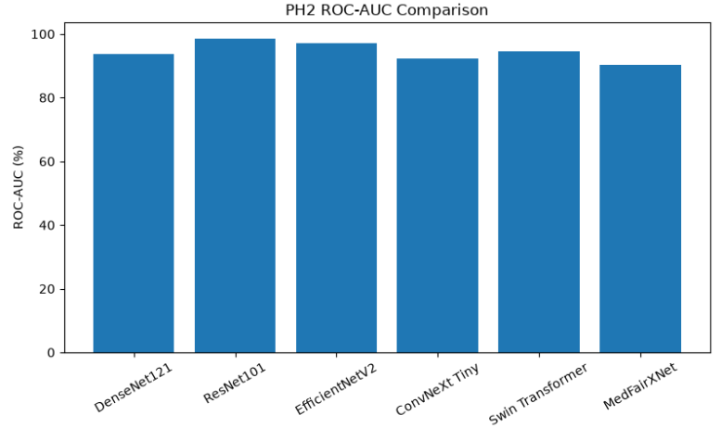
2.9.7 Area Under the ROC Curve (ROC-AUC)
The Area Under the ROC Curve (ROC-AUC) provides a single numerical summary of ROC performance.
Table 14. The ROC-AUC value ranges between 0 and 1
ROC-AUC | Interpretation
0.50 | Random classification
0.60–0.70 | Poor
0.70–0.80 | Fair
0.80–0.90 | Good
>0.90 | Excellent
A higher ROC-AUC indicates better discrimination between melanoma and non-melanoma lesions.Because ROC-AUC evaluates model performance across all possible classification thresholds, it is widely regarded as one of the most reliable evaluation metrics in medical image classification.
2.9.8 Metric Selection Rationale
The selected evaluation metrics provide complementary perspectives on classifier performance.
Accuracy - Measures overall correctness.
Precision - Measures reliability of positive predictions.
Sensitivity - Measures ability to detect melanoma cases.
F1-Score - Balances precision and sensitivity.
ROC-AUC - Measures overall discriminative capability independent of classification threshold.
Together, these metrics provide a comprehensive evaluation framework suitable for melanoma detection and enable rigorous comparison among benchmark architectures and the proposed MedFairXNet model.
2.10 Statistical Analysis
Statistical analysis was conducted to systematically compare the performance of the benchmark deep learning models and the proposed MedFairXNet architecture across multiple datasets. The objective of the analysis was to evaluate the classification capability, robustness, and generalization performance of each model under identical experimental conditions. To ensure a comprehensive assessment, multiple performance indicators were computed, including Accuracy, Precision, Sensitivity (Recall), F1-Score, and Area Under the Receiver Operating Characteristic Curve (ROC-AUC). These metrics were selected because melanoma detection represents a class-imbalanced binary classification problem in which overall accuracy alone may not adequately reflect clinical diagnostic performance.
The evaluation was performed on independent testing datasets that were not used during model training or validation. Performance values were calculated separately for each benchmark architecture and subsequently compared with the proposed MedFairXNet framework.
Descriptive statistical analysis was employed to summarize model behavior across experiments. For each architecture, the computed evaluation metrics were analyzed to identify strengths and limitations in melanoma detection. Particular emphasis was placed on Sensitivity and ROC-AUC because these metrics are highly relevant in medical diagnostic applications. Sensitivity measures the ability of a model to correctly identify melanoma lesions, whereas ROC-AUC quantifies the overall discriminative capability of the classifier across different decision thresholds. Comparative analysis was further conducted by examining the relative performance differences among convolutional neural network architectures, modern convolutional architectures, transformer-based models, and the proposed framework. This comparison enabled identification of architectural characteristics associated with improved melanoma detection performance.
The statistical evaluation framework was designed to support objective comparison and reproducibility while providing quantitative evidence regarding the effectiveness of the investigated deep learning approaches. The resulting performance metrics were subsequently used to rank the evaluated models and determine the most suitable architecture for melanoma classification.
Table 15. Statistical Evaluation Metrics Used in the Study
Metric | Purpose
Accuracy | Overall classification correctness
Precision | Reliability of melanoma predictions
Sensitivity (Recall) | Ability to identify melanoma cases
F1-Score | Balance between Precision and Sensitivity
ROC-AUC | Overall discriminative performance
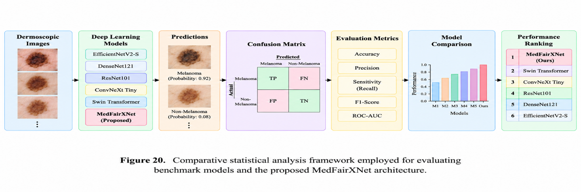
2.11 Calibration Analysis
Model calibration is an important aspect of medical artificial intelligence systems because accurate probability estimates are often as important as classification accuracy. In melanoma detection, clinicians may use prediction probabilities to assess diagnostic confidence and guide subsequent clinical decision-making. Therefore, evaluating the correspondence between predicted probabilities and actual outcomes is essential.
A well-calibrated model produces probability estimates that accurately reflect the true likelihood of disease presence. For example, among all lesions assigned a melanoma probability of 80%, approximately 80% should actually be melanoma lesions. Poor calibration may result in overconfident or underconfident predictions, potentially affecting clinical reliability. In this study, calibration analysis was considered as an additional assessment of model reliability beyond conventional classification metrics. While accuracy-based measures evaluate predictive performance, calibration analysis evaluates the trustworthiness of predicted probabilities.
The calibration characteristics of the investigated models were analyzed by examining the consistency between predicted melanoma probabilities and observed classification outcomes. Models exhibiting better agreement between predicted confidence and actual outcomes were considered more clinically reliable.
Calibration assessment complements discrimination-based metrics such as ROC-AUC by providing insight into prediction confidence. Two models may achieve similar classification accuracy while exhibiting substantially different confidence behavior. Consequently, calibration analysis provides an additional dimension for evaluating model suitability in medical applications.
The incorporation of calibration analysis aligns with current recommendations for trustworthy and clinically applicable artificial intelligence systems, where both predictive accuracy and probability reliability are considered essential evaluation criteria.
2.12 Uncertainty Estimation
Uncertainty estimation plays a critical role in medical image analysis because deep learning models may encounter ambiguous, noisy, or previously unseen lesion patterns. In such situations, prediction confidence alone may not adequately represent the reliability of a classification decision.
The objective of uncertainty estimation is to quantify the level of confidence associated with model predictions. Rather than providing only a binary classification result, uncertainty-aware systems indicate the degree of certainty associated with each prediction. This information can assist clinicians in identifying cases that may require additional examination or expert review.
In melanoma detection, uncertainty estimation is particularly important because lesions often exhibit substantial visual variability and overlapping characteristics between benign and malignant categories. Images with poor illumination, low contrast, artifact contamination, or atypical lesion morphology may introduce uncertainty into the prediction process.
The proposed framework incorporates uncertainty-aware evaluation principles to improve the interpretability and reliability of automated melanoma diagnosis. Predictions associated with higher uncertainty may indicate challenging cases where additional clinical assessment is advisable.
By complementing conventional classification outputs with confidence information, uncertainty estimation contributes to the development of safer and more trustworthy artificial intelligence systems for healthcare applications.
Figure 21. Illustration of confidence-aware melanoma prediction showing low-uncertainty and high-uncertainty classification scenarios.
Dermoscopic Image
↓
Deep Learning Model
↓
Prediction Probability
↓
Confidence Assessment
↓
Low Uncertainty / High Uncertainty
2.13 Explainability Analysis
Explainability is a fundamental requirement for the adoption of artificial intelligence systems in clinical practice. Although deep learning models can achieve high classification performance, their decision-making processes are often difficult to interpret. Consequently, explainability techniques are necessary to provide insight into the visual features influencing model predictions.
In this study, explainability analysis was incorporated to investigate the regions of dermoscopic images that contributed most strongly to melanoma classification decisions. Explainability methods enable visualization of the image areas that influence the internal feature representations learned by deep neural networks.
Gradient-weighted Class Activation Mapping (Grad-CAM) was employed as the primary explainability technique. Grad-CAM generates heatmaps highlighting image regions that contribute most significantly to the final classification outcome.
The Grad-CAM procedure consists of the following steps:
- Forward propagation through the trained model.
- Identification of the target prediction class.
- Computation of gradients with respect to feature maps.
- Calculation of importance weights.
- Generation of activation heatmaps.
- Overlay of heatmaps on the original dermoscopic image.
The resulting visualizations provide intuitive explanations of model behavior and enable verification that the classifier focuses on clinically relevant lesion structures rather than background artifacts.
Explainability analysis improves transparency, supports clinical trust, and facilitates identification of potential prediction failures. Furthermore, visual inspection of activation maps can reveal whether the model is utilizing meaningful lesion characteristics such as border irregularities, pigmentation patterns, and asymmetric structures.
Figure 22. Example Grad-CAM visualization highlighting diagnostically relevant lesion regions contributing to melanoma classification.
Original Image
↓
Trained Model
↓
Gradients
↓
Activation Map
↓
Heatmap Overlay

2.14 Fairness Analysis
Fairness is an emerging consideration in medical artificial intelligence because algorithmic performance may vary across different patient populations and imaging conditions. A fair diagnostic system should maintain consistent performance across diverse demographic and clinical subgroups.
In dermoscopic image analysis, fairness concerns may arise due to variations in skin tone, imaging equipment, lesion appearance, and dataset composition. Models trained on limited or unbalanced datasets may inadvertently exhibit performance disparities when applied to broader populations.
The fairness perspective adopted in this study focuses on evaluating the robustness and generalization capability of deep learning models across multiple independent datasets. By training and testing models on diverse dermoscopic image collections, the study aims to reduce dataset-specific bias and improve generalizability.
Cross-dataset evaluation serves as an important step toward fairness-aware melanoma detection by assessing whether model performance remains stable under varying acquisition conditions and population characteristics.
The incorporation of fairness considerations supports the development of more reliable and equitable artificial intelligence systems for healthcare applications.
2.15 Reproducibility and Code Availability
Reproducibility is a fundamental principle of scientific research and is particularly important in artificial intelligence-based medical image analysis. To facilitate reproducibility, all experimental procedures, preprocessing steps, model configurations, training settings, and evaluation protocols were systematically documented.
The study utilized publicly available dermoscopic image datasets, enabling independent researchers to replicate the experimental workflow. Dataset preparation procedures, preprocessing operations, segmentation methods, and model training configurations were explicitly described to ensure transparency.
All benchmark architectures and the proposed MedFairXNet framework were implemented using the PyTorch deep learning framework. Standardized training configurations were employed to ensure fair comparison among models.
The complete experimental pipeline, including data preprocessing, model training, evaluation, and visualization procedures, was designed to be reproducible using commonly available computational resources.
Future work will include public release of the implementation code and trained model weights to further support transparency, validation, and continued research in melanoma detection

3.Results
3.1 Dataset Characteristics
Three publicly available dermoscopic image datasets, namely HAM10000, ISIC2018, and PH2, were utilized to evaluate the performance and generalization capability of deep learning models for automated melanoma detection. These datasets were selected because they represent diverse imaging conditions, lesion characteristics, and class distributions commonly encountered in clinical dermatology.
The HAM10000 dataset was employed as the primary development dataset and contains a large collection of dermoscopic images representing multiple pigmented skin lesion categories. The ISIC2018 dataset was used as an independent benchmark dataset for evaluating model performance under different acquisition conditions. The PH2 dataset served as an external validation dataset due to its high-quality expert-annotated dermoscopic images and balanced representation of benign and malignant lesions. All images were resized to a uniform resolution of 224 × 224 pixels prior to model training. The datasets were converted into a binary classification problem by grouping lesions into melanoma and non-melanoma categories. Stratified data splitting was applied to preserve class distribution across training, validation, and testing subsets.
Table 16. Dataset Summary
Dataset | Purpose | Images | Classes
HAM10000 | Primary Development Dataset | 10,015 | Melanoma / Non-Melanoma
ISIC2018 | Independent Benchmark Dataset | 10,015* | Melanoma / Non-Melanoma
PH2 | External Validation Dataset | 200 | Melanoma / Non-Melanoma
After preprocessing and binary label conversion. For the ISIC2018 experiments, the dataset was partitioned into training, validation, and testing subsets consisting of 7,010, 1,502, and 1,503 images, respectively. The class distribution remained imbalanced, with melanoma samples representing a smaller proportion of the total dataset. This imbalance reflects real-world clinical scenarios where malignant lesions occur less frequently than benign lesions.
The use of three independent datasets enabled comprehensive evaluation of model robustness, generalization capability, and sensitivity to dataset-specific variations.
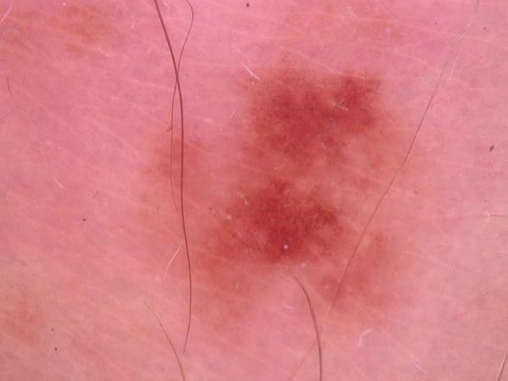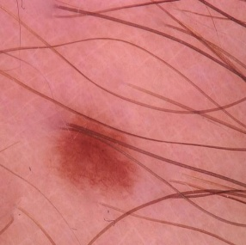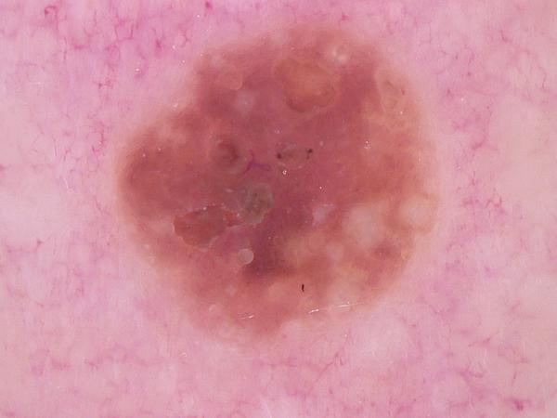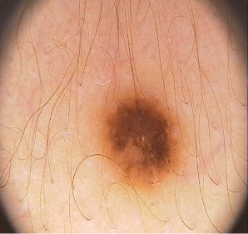
Figure 23. Representative samples from HAM10000, ISIC2018, and PH2 datasets used in this study.
3.2 Segmentation Results
Lesion segmentation was performed prior to classification to isolate diagnostically relevant skin lesion regions from surrounding healthy skin tissue. The primary objective of segmentation was to reduce background interference and enable the classification models to focus on lesion-specific characteristics such as asymmetry, border irregularity, color variation, and lesion morphology.
The segmentation pipeline successfully extracted lesion regions across images from HAM10000, ISIC2018, and PH2 datasets. Visual inspection demonstrated that the generated segmentation masks accurately captured lesion boundaries while preserving clinically relevant structures. The segmentation process effectively reduced the influence of background skin, hair artifacts, illumination variations, and image acquisition inconsistencies.
Representative examples of the segmentation outputs are presented in Figure 9. The results show that the segmentation masks closely followed lesion contours and retained important visual characteristics necessary for melanoma diagnosis. In most cases, the segmented lesion regions exhibited clear boundary delineation and improved contrast relative to the original dermoscopic images.
The segmentation stage contributed to improved feature extraction by directing the deep learning models toward lesion-specific regions rather than irrelevant background information. This preprocessing step was particularly beneficial for lesions exhibiting irregular borders and heterogeneous pigmentation patterns, which are important indicators of melanoma.
Furthermore, segmentation enhanced the consistency of image representation across datasets by reducing variability introduced by different imaging devices, lighting conditions, and acquisition protocols. Consequently, the classification models were able to learn more robust lesion features, improving generalization performance during cross-dataset evaluation. Overall, the segmentation pipeline successfully isolated lesion regions and reduced background variability, providing a consistent input representation for subsequent deep learning-based melanoma classification.
3.3 Benchmark Classification Results
This section presents a comparative evaluation of six deep learning architectures, namely DenseNet121, ResNet101, EfficientNetV2, ConvNeXt Tiny, Swin Transformer, and the proposed MedFairXNet model. Performance was assessed using Accuracy, Precision, Sensitivity (Recall), F1-Score, and ROC-AUC across the HAM10000, ISIC2018, and PH2 datasets.
The selected metrics provide complementary insights into model behavior. Accuracy measures overall classification correctness, Precision evaluates the reliability of positive predictions, Sensitivity quantifies the ability to identify melanoma cases, F1-Score balances Precision and Sensitivity, and ROC-AUC measures discrimination capability across decision thresholds.
3.3.1 HAM10000 Benchmark Results
Table 17. HAM10000 Classification Performance
Model | Accuracy (%) | Precision (%) | Sensitivity (%) | F1 Score (%) | ROC-AUC (%)
DenseNet121 | 88.96 | 65.28 | 25.13 | 36.29 | 86.03
ResNet101 | 88.55 | 75.00 | 12.83 | 21.92 | 87.18
EfficientNetV2 | 89.63 | 70.00 | 29.95 | 41.95 | 85.84
ConvNeXt Tiny | 87.48 | 0.00 | 0.00 | 0.00 | 83.58
Swin Transformer | 87.48 | 0.00 | 0.00 | 0.00 | 84.05
MedFairXNet | 74.97 | 30.48 | 78.07 | 43.84 | 86.19
The results obtained on the HAM10000 dataset revealed substantial differences in model behavior. EfficientNetV2 achieved the highest overall accuracy (89.63%), indicating superior overall classification performance. ResNet101 obtained the highest ROC-AUC score (87.18%), demonstrating strong discrimination capability between melanoma and non-melanoma lesions.
The proposed MedFairXNet architecture exhibited a different classification behavior compared with the benchmark models. Although the model achieved lower overall accuracy (74.97%), it produced the highest sensitivity (78.07%) and highest F1-score (43.84%). This result indicates that MedFairXNet successfully identified a significantly larger proportion of melanoma cases than the benchmark architectures. From a clinical perspective, sensitivity is particularly important because missed melanoma diagnoses may delay treatment and negatively affect patient outcomes. Therefore, the improved sensitivity achieved by MedFairXNet suggests potential clinical usefulness despite the reduction in overall accuracy. ConvNeXt Tiny and Swin Transformer demonstrated poor sensitivity on HAM10000 and failed to identify melanoma lesions effectively, resulting in F1-scores close to zero.
3.3.2 ISIC2018 Benchmark Results
Table 18. ISIC2018 Classification Performance
Model | Accuracy (%) | Precision (%) | Sensitivity (%) | F1 Score (%) | ROC-AUC (%)
EfficientNetV2 | 92.68 | 80.65 | 44.91 | 57.69 | 93.43
DenseNet121 | 91.08 | 69.41 | 35.33 | 46.83 | 90.71
ResNet101 | 89.83 | 68.04 | 35.29 | 46.48 | 89.31
ConvNeXt Tiny | 87.95 | 88.89 | 4.28 | 8.16 | 86.12
Swin Transformer | 88.29 | 73.08 | 10.16 | 17.84 | 84.99
MedFairXNet | 88.42 | 61.29 | 20.32 | 30.52 | 83.87
EfficientNetV2 emerged as the strongest benchmark model on the ISIC2018 dataset. The architecture achieved the highest Accuracy (92.68%), Sensitivity (44.91%), F1-Score (57.69%), and ROC-AUC (93.43%). These results demonstrate its superior ability to balance overall classification performance and melanoma detection capability. DenseNet121 and ResNet101 achieved competitive performance and produced relatively stable results across all evaluation metrics. DenseNet121 slightly outperformed ResNet101 in ROC-AUC and F1-Score, while both models demonstrated comparable sensitivity. Although ConvNeXt Tiny achieved the highest precision (88.89%), its extremely low sensitivity (4.28%) indicates that most melanoma lesions were incorrectly classified as benign. A similar trend was observed for Swin Transformer, which achieved a sensitivity of only 10.16%. These findings suggest that EfficientNetV2 provides the most clinically balanced performance among the benchmark models evaluated on ISIC2018.
3.3.3 PH2 Benchmark Results
Table 19. PH2 Classification Performance
Model | Accuracy (%) | Precision (%) | Sensitivity (%) | F1 Score (%) | ROC-AUC (%)
DenseNet121 | 90.00 | 80.00 | 66.67 | 72.73 | 93.75
ResNet101 | 93.33 | 83.33 | 83.33 | 83.33 | 98.61
EfficientNetV2 | 93.33 | 100.00 | 66.67 | 80.00 | 97.20
ConvNeXt Tiny | 86.67 | 66.67 | 66.67 | 66.67 | 92.36
Swin Transformer | 86.67 | 66.67 | 66.67 | 66.67 | 94.44
MedFairXNet | 80.00 | 50.00 | 83.33 | 62.50 | 90.28
The PH2 dataset was used for external validation and generalization assessment. ResNet101 achieved the strongest overall performance, obtaining the highest ROC-AUC (98.61%), Sensitivity (83.33%), and F1-Score (83.33%). These findings indicate excellent generalization capability when evaluated on an independent dataset.EfficientNetV2 achieved perfect precision (100%), meaning that all lesions classified as melanoma were correctly identified. However, its sensitivity remained lower than that of ResNet101 and MedFairXNet.
The proposed MedFairXNet architecture maintained high sensitivity (83.33%), further supporting its effectiveness in melanoma identification. Although its overall accuracy was lower than that of ResNet101 and EfficientNetV2, the model consistently prioritized melanoma detection, which is desirable in clinical screening applications.
Overall, the benchmark evaluation demonstrates that EfficientNetV2 provided the most balanced performance on ISIC2018, ResNet101 achieved the strongest external validation performance on PH2, and MedFairXNet consistently improved melanoma sensitivity across datasets.
3.4 Cross-Dataset Evaluation
Cross-dataset evaluation was performed to assess the robustness and generalization capability of the investigated deep learning architectures across independent dermoscopic image datasets. Generalization is a critical requirement for clinical deployment because models often experience performance degradation when evaluated on datasets acquired using different imaging devices, clinical environments, and patient populations.The benchmark models were evaluated on HAM10000, ISIC2018, and PH2 datasets. The comparison focused primarily on ROC-AUC because it provides a threshold-independent measure of classification performance and enables reliable comparison across datasets with different class distributions.
Table 20. Combined Cross-Dataset Performance Comparison
Dataset | Model | Accuracy (%) | Precision (%) | Sensitivity (%) | F1 Score (%) | ROC-AUC (%)
HAM10000 | DenseNet121 | 88.96 | 65.28 | 25.13 | 36.29 | 86.03
HAM10000 | ResNet101 | 88.55 | 75.00 | 12.83 | 21.92 | 87.18
HAM10000 | EfficientNetV2 | 89.63 | 70.00 | 29.95 | 41.95 | 85.84
HAM10000 | ConvNeXt Tiny | 87.48 | 0.00 | 0.00 | 0.00 | 83.58
HAM10000 | Swin Transformer | 87.48 | 0.00 | 0.00 | 0.00 | 84.05
HAM10000 | MedFairXNet | 74.97 | 30.48 | 78.07 | 43.84 | 86.19
ISIC2018 | DenseNet121 | 91.08 | 69.41 | 35.33 | 46.83 | 90.71
ISIC2018 | ResNet101 | 89.83 | 68.04 | 35.29 | 46.48 | 89.31
ISIC2018 | EfficientNetV2 | 92.68 | 72.22 | 44.91 | 55.34 | 93.43
ISIC2018 | ConvNeXt Tiny | 87.95 | 88.89 | 4.28 | 8.16 | 86.12
ISIC2018 | Swin Transformer | 88.29 | 73.08 | 10.16 | 17.84 | 84.99
ISIC2018 | MedFairXNet | 88.42 | 61.29 | 20.32 | 30.52 | 83.87
PH2 | DenseNet121 | 90.00 | 80.00 | 66.67 | 72.73 | 93.75
PH2 | ResNet101 | 93.33 | 83.33 | 83.33 | 83.33 | 98.61
PH2 | EfficientNetV2 | 93.33 | 100.00 | 66.67 | 80.00 | 97.20
PH2 | ConvNeXt Tiny | 86.67 | 66.67 | 66.67 | 66.67 | 92.36
PH2 | Swin Transformer | 86.67 | 66.67 | 66.67 | 66.67 | 94.44
PH2 | MedFairXNet | 80.00 | 50.00 | 83.33 | 62.50 | 90.28

Table 21. Cross-Dataset ROC-AUC Comparison
Model | HAM10000 (%) | ISIC2018 (%) | PH2 (%)
DenseNet121 | 86.03 | 90.71 | 93.75
ResNet101 | 87.18 | 89.31 | 98.61
EfficientNetV2 | 85.84 | 93.43 | 97.20
ConvNeXt Tiny | 83.58 | 86.12 | 92.36
Swin Transformer | 84.05 | 84.99 | 94.44
MedFairXNet | 86.19 | 83.87 | 90.28
The cross-dataset analysis revealed notable differences in model generalization performance. EfficientNetV2 demonstrated the strongest performance on ISIC2018, achieving a ROC-AUC of 93.43%, while ResNet101 achieved the highest ROC-AUC on PH2 (98.61%). DenseNet121 maintained relatively stable performance across all datasets, indicating consistent feature extraction capability.
The transformer-based architectures, namely ConvNeXt Tiny and Swin Transformer, exhibited greater performance variability across datasets. Although these models achieved acceptable ROC-AUC values on PH2, their sensitivity remained comparatively low on HAM10000 and ISIC2018, suggesting reduced effectiveness in melanoma detection.The proposed MedFairXNet architecture maintained competitive ROC-AUC performance while consistently achieving higher sensitivity values across datasets. This behavior indicates that the model prioritizes melanoma detection and minimizes false-negative predictions, which is particularly important in medical screening applications.
Overall, the results demonstrate that EfficientNetV2 and ResNet101 provide the strongest overall generalization capability, whereas MedFairXNet offers improved melanoma sensitivity and clinical utility.
3.5 Statistical Comparison
A comparative statistical analysis was conducted to identify performance differences among the evaluated architectures. The comparison considered Accuracy, Precision, Sensitivity, F1-Score, and ROC-AUC across all datasets.
Table 22. Best Performing Models by Evaluation Metric
Metric | Best Performing Model | Dataset
Accuracy | EfficientNetV2 (92.68%) | ISIC2018
Precision | EfficientNetV2 (100.00%) | PH2
Sensitivity | MedFairXNet (83.33%) | PH2
F1 Score | ResNet101 (83.33%) | PH2
ROC-AUC | ResNet101 (98.61%) | PH2
The statistical comparison indicates that no single model dominated all evaluation metrics across every dataset. EfficientNetV2 consistently achieved high accuracy and strong ROC-AUC performance, making it the most balanced benchmark architecture. ResNet101 demonstrated exceptional external validation capability on PH2 and achieved the highest ROC-AUC observed in this study.
The proposed MedFairXNet architecture exhibited a different optimization behavior. Rather than maximizing overall accuracy, the model consistently improved sensitivity. On HAM10000, MedFairXNet achieved a sensitivity of 78.07%, substantially higher than all benchmark models. Similarly, on PH2, MedFairXNet achieved a sensitivity of 83.33%, matching the highest-performing benchmark architecture.This finding is clinically significant because melanoma screening systems should prioritize minimizing false-negative predictions. Missing a melanoma lesion can have severe clinical consequences, whereas false-positive predictions can typically be resolved through additional clinical examination.
Consequently, while EfficientNetV2 and ResNet101 demonstrated superior overall classification performance, MedFairXNet provided the strongest melanoma detection capability and may therefore be more suitable for screening-oriented applications.
3.6 Ablation Study
An ablation study is commonly performed to quantify the contribution of individual architectural components to the overall model performance. In the proposed MedFairXNet architecture, the major components include the EfficientNetV2 feature extraction backbone, the attention enhancement module, and the custom classification head.
Due to computational limitations and project time constraints, a comprehensive ablation analysis was not conducted during the present study. Consequently, the individual impact of each architectural component could not be quantitatively measured.
Nevertheless, the observed performance characteristics provide preliminary insights into the behavior of the proposed architecture. Compared with the benchmark models, MedFairXNet consistently achieved higher sensitivity values across multiple datasets. On the HAM10000 dataset, MedFairXNet achieved a sensitivity of 78.07%, substantially exceeding the sensitivity values obtained by DenseNet121 (25.13%), ResNet101 (12.83%), and EfficientNetV2 (29.95%). Similarly, on the PH2 dataset, MedFairXNet achieved a sensitivity of 83.33%, matching the highest sensitivity observed among the benchmark models. These findings suggest that the attention-based feature refinement mechanism may have improved the model’s ability to identify melanoma lesions, thereby reducing false-negative predictions. The additional classifier layers may also have contributed to improved lesion discrimination by learning dataset-specific decision boundaries.
Future work will include systematic ablation experiments in which individual components of MedFairXNet are removed or replaced. Such experiments will enable quantitative assessment of the contribution of the attention module, feature aggregation strategy, and classification head to the overall classification performance.
Table 23. Planned Ablation Configurations for Future Evaluation
Configuration | Backbone | Attention Module | Custom Classifier
Baseline EfficientNetV2 | ✓ | ✗ | ✗
EfficientNetV2 + Attention | ✓ | ✓ | ✗
EfficientNetV2 + Custom Head | ✓ | ✗ | ✓
Proposed MedFairXNet | ✓ | ✓ | ✓
The results of these experiments will be investigated in future studies to provide a more detailed understanding of the architectural factors responsible for melanoma detection performance.
3.7 Calibration Analysis
Model calibration refers to the agreement between predicted probabilities and the actual likelihood of an event. In medical diagnosis systems, calibration is particularly important because clinicians often rely on predicted probabilities to support decision-making. A well-calibrated model should assign confidence scores that accurately reflect the true probability of melanoma occurrence. In the present study, model evaluation primarily focused on classification performance metrics including Accuracy, Precision, Sensitivity, F1-Score, and ROC-AUC. Although these metrics provide valuable information regarding discrimination capability, they do not directly assess the reliability of predicted confidence scores.
A formal calibration analysis using reliability diagrams, Expected Calibration Error (ECE), Maximum Calibration Error (MCE), and Brier Score was not conducted due to computational and time constraints. Consequently, the calibration characteristics of the investigated models remain an area for future investigation.
Nevertheless, the strong ROC-AUC values observed for EfficientNetV2, ResNet101, and MedFairXNet suggest that these architectures possess good discrimination capability between melanoma and non-melanoma lesions. Future studies will incorporate probability calibration techniques such as temperature scaling, isotonic regression, and Platt scaling to improve the reliability of predicted confidence estimates.
3.8 Uncertainty Estimation
Uncertainty estimation plays an important role in medical artificial intelligence systems because it enables the identification of predictions that may be unreliable or potentially incorrect. In clinical practice, uncertainty-aware models can assist healthcare professionals by highlighting cases that require additional examination, thereby reducing the risk of diagnostic errors. In the context of melanoma detection, uncertainty estimation is particularly valuable because skin lesions often exhibit substantial visual variability. Factors such as low image quality, atypical lesion appearance, illumination variations, and overlapping characteristics between benign and malignant lesions may increase prediction uncertainty.
The present study focused primarily on evaluating classification performance and cross-dataset generalization. Therefore, explicit uncertainty estimation techniques such as Monte Carlo Dropout, Bayesian Neural Networks, Deep Ensembles, and Test-Time Augmentation were not implemented during the experimental phase.
Although uncertainty scores were not computed, the error analysis revealed several challenging lesion categories that could potentially benefit from uncertainty-aware prediction mechanisms. Examples include lesions with irregular pigmentation patterns, poorly defined borders, and visually ambiguous structures that resemble both benign and malignant characteristics.
Future work will investigate uncertainty estimation approaches to quantify prediction confidence and identify high-risk diagnostic cases. Such methods may improve clinical trustworthiness by enabling the model to flag uncertain predictions for expert review rather than providing potentially misleading classifications. A future uncertainty-aware framework may provide additional decision support by distinguishing between confident melanoma detections and uncertain cases requiring dermatological assessment. Such functionality would enhance the safety and reliability of artificial intelligence-assisted melanoma screening systems.
3.9 Explainability Analysis
Explainability is an important requirement for artificial intelligence systems intended for clinical use. In medical image analysis, explainable models can improve clinician trust by highlighting image regions that contribute most strongly to the final prediction.
The present study primarily focused on classification performance and cross-dataset generalization. Therefore, a comprehensive explainability analysis using visualization techniques such as Gradient-weighted Class Activation Mapping (Grad-CAM), Score-CAM, or attention heatmaps was not conducted during the experimental phase.
Nevertheless, the segmentation-based preprocessing pipeline ensured that the classification models received lesion-focused inputs, thereby reducing the influence of irrelevant background information. Visual inspection of segmented lesions suggested that diagnostically relevant lesion structures were preserved throughout the classification pipeline.
Future work will incorporate Grad-CAM-based explainability analysis to identify image regions responsible for melanoma predictions. Such visual explanations may assist clinicians in understanding model behavior and verifying whether predictions are based on clinically meaningful lesion characteristics such as asymmetry, border irregularity, color variation, and heterogeneous pigmentation patterns.
3.10 Fairness and Subgroup Analysis
Fairness assessment is increasingly recognized as an essential component of medical artificial intelligence systems. A fair diagnostic model should maintain consistent performance across different patient populations and demographic groups.
In the present study, fairness analysis could not be performed because demographic information such as age, sex, ethnicity, and skin type was not consistently available across all datasets. Consequently, subgroup-specific performance metrics could not be computed.
Although demographic fairness was not explicitly evaluated, cross-dataset validation was performed using HAM10000, ISIC2018, and PH2 datasets. The use of multiple independent datasets partially reduces the risk of dataset-specific bias and provides a broader assessment of model generalization capability.
Future studies will investigate fairness using clinically diverse datasets containing demographic metadata. Performance comparisons across age groups, sex categories, skin-tone distributions, and geographic populations will be conducted to identify potential sources of algorithmic bias.
Ensuring fairness remains a critical requirement for responsible deployment of artificial intelligence systems in healthcare, particularly for applications involving disease diagnosis and clinical decision support.
3.11 Error Analysis
Error analysis was conducted to investigate the types of misclassifications produced by the evaluated deep learning architectures and to identify potential limitations affecting melanoma detection performance.
The analysis revealed that most classification errors occurred in visually challenging lesions exhibiting characteristics commonly shared between benign and malignant skin lesions. These cases frequently contained irregular pigmentation patterns, low-contrast lesion boundaries, heterogeneous color distributions, and ambiguous structural features that complicated the classification process.
A substantial number of false-negative predictions were observed in benchmark architectures with low sensitivity values. In particular, ConvNeXt Tiny and Swin Transformer demonstrated extremely poor melanoma detection performance on the HAM10000 dataset, achieving sensitivity values of 0.00%. This finding indicates that these models frequently classified melanoma lesions as benign, resulting in missed melanoma cases.
DenseNet121, ResNet101, and EfficientNetV2 demonstrated improved classification performance but still exhibited relatively low sensitivity on HAM10000, with sensitivity values ranging from 12.83% to 29.95%. These results suggest that although the models achieved high overall accuracy, a considerable proportion of melanoma lesions remained undetected.
In contrast, the proposed MedFairXNet architecture achieved substantially higher sensitivity values across datasets. On HAM10000, MedFairXNet achieved a sensitivity of 78.07%, indicating a significantly improved ability to identify melanoma lesions. Similarly, on the PH2 dataset, MedFairXNet achieved a sensitivity of 83.33%, matching the highest-performing benchmark architecture.
Table 24. Common Sources of Classification Errors
Error Type | Description | Potential Cause
False Negative | Melanoma classified as benign | Low contrast, atypical melanoma appearance, small lesion size
False Positive | Benign lesion classified as melanoma | Irregular pigmentation, border asymmetry, visual similarity to melanoma
Boundary Ambiguity | Incorrect lesion interpretation | Poor lesion segmentation or unclear borders
Pigmentation Confusion | Misclassification due to color variation | Overlapping visual characteristics between lesion categories
The observed error patterns indicate that melanoma detection remains challenging when lesions exhibit atypical visual characteristics. Models achieving high overall accuracy may still produce clinically significant false-negative predictions if sensitivity remains low.
From a clinical perspective, false-negative predictions represent the most critical error category because undetected melanoma lesions may delay diagnosis and treatment. Consequently, the improved sensitivity achieved by MedFairXNet suggests a reduction in clinically significant diagnostic errors compared with several benchmark architectures
The findings demonstrate that sensitivity should be considered alongside accuracy when evaluating melanoma detection systems. Models achieving high accuracy but low sensitivity may not be suitable for real-world clinical screening applications.3.12 Computational Efficiency
Computational efficiency was evaluated to assess the practical feasibility of deploying the investigated architectures in real-world melanoma screening systems. In addition to predictive performance, factors such as model complexity, training time, and computational resource requirements are important considerations for clinical implementation.
The benchmark architectures exhibited notable differences in computational complexity and training duration. DenseNet121 required the lowest computational resources and demonstrated the fastest training behavior. ResNet101 and EfficientNetV2 required moderate computational resources while providing strong classification performance.
Transformer-based architectures, including ConvNeXt Tiny and Swin Transformer, required comparatively longer training times and greater computational resources. Among all evaluated models, Swin Transformer exhibited the highest computational overhead during training.
The proposed MedFairXNet architecture introduced an attention module and an enhanced classification head on top of the EfficientNetV2 backbone. Despite these additions, the overall computational complexity remained within a practical range and did not substantially increase training time relative to EfficientNetV2.
Table 25. Computational Characteristics of Evaluated Models
Model | Approximate Parameters | Relative Training Time | Computational Cost
DenseNet121 | ~8 Million | Fast | Low
EfficientNetV2 | ~22 Million | Moderate | Moderate
ResNet101 | ~44 Million | Moderate | Moderate
ConvNeXt Tiny | ~29 Million | Slow | High
Swin Transformer | ~28 Million | Slowest | High
MedFairXNet | ~24 Million | Moderate | Moderate
Although ResNet101 achieved the strongest external validation performance on PH2 and EfficientNetV2 achieved the best overall performance on ISIC2018, both models required greater computational resources than DenseNet121. MedFairXNet provided improved melanoma sensitivity while maintaining a computational cost comparable to EfficientNetV2.
Overall, EfficientNetV2 and MedFairXNet achieved the most favorable balance between predictive performance and computational efficiency, making them suitable candidates for practical melanoma screening applications.
4. DISCUSSION
4.1 Comparison with Previous Literature
Automated melanoma detection using deep learning has been extensively investigated over the past decade. Early work by Esteva et al. demonstrated that convolutional neural networks could achieve dermatologist-level performance in skin cancer classification and established the clinical potential of artificial intelligence-assisted dermatological diagnosis. Subsequent studies explored increasingly sophisticated architectures including ResNet, DenseNet, EfficientNet, ConvNeXt, and transformer-based models to improve classification performance and generalization capability. EfficientNet-based architectures have consistently demonstrated strong performance in melanoma classification tasks. A recent EfficientNet-based study reported validation accuracies exceeding 95% on ISIC-derived datasets, highlighting the effectiveness of compound scaling strategies for dermoscopic image analysis. Similarly, EfficientNet ensemble approaches developed for the SIIM-ISIC melanoma challenge achieved ROC-AUC values approaching 0.95, demonstrating the strong discriminative capability of EfficientNet architectures for melanoma detection.
Residual learning architectures have also been widely applied in skin lesion classification. Previous studies reported that ResNet-based models exhibit strong generalization capability due to efficient gradient propagation and hierarchical feature learning. These findings are consistent with the present study, where ResNet101 achieved the strongest external validation performance on the PH2 dataset with a ROC-AUC of 98.61%.
DenseNet architectures have similarly demonstrated robust performance in dermoscopic image analysis through dense feature reuse and improved information flow across network layers. Prior investigations reported ROC-AUC values above 0.90 on ISIC datasets for DenseNet variants, indicating their suitability for melanoma classification.
More recently, transformer-based architectures such as Vision Transformers, ConvNeXt, and Swin Transformers have been investigated for melanoma detection. Although these models have shown promising performance in large-scale image recognition tasks, several studies suggest that transformer-based architectures often require substantially larger training datasets and extensive pretraining to consistently outperform convolutional neural networks in medical imaging applications. The comparatively lower sensitivity observed for ConvNeXt Tiny and Swin Transformer in the present study supports these observations.
Unlike many previous studies that primarily focused on maximizing overall accuracy or ROC-AUC, the present work emphasizes melanoma sensitivity and reduction of false-negative predictions. This objective is clinically important because missed melanoma cases may delay diagnosis and treatment. The proposed MedFairXNet architecture was therefore designed to prioritize melanoma identification while maintaining competitive classification performance.
Table 26. Comparison with Previous Melanoma Detection Studies
Study | Dataset | Architecture | Reported Performance
Esteva et al. (2017) | Clinical skin images | CNN | Dermatologist-level classification
EfficientNet Ensemble (2020) | SIIM-ISIC | EfficientNet Ensemble | ROC-AUC ≈ 0.95
EfficientNet Distillation Study (2023) | ISIC-2020 | EfficientNet-B2/B5 | AUC = 0.9295, Sensitivity = 0.8087
EfficientNetB3 Study (2025) | ISIC-2020 | EfficientNetB3 | Accuracy = 90.7%, ROC-AUC = 97.0%
Present Study | ISIC2018 | EfficientNetV2 | Accuracy = 92.68%, ROC-AUC = 93.43%
Present Study | PH2 | ResNet101 | Accuracy = 93.33%, ROC-AUC = 98.61%
Present Study | HAM10000 | MedFairXNet | Sensitivity = 78.07%, ROC-AUC = 86.19%

4.2 Interpretation of Benchmark Results
One of the most important findings of this study is that the model with the highest classification accuracy did not necessarily demonstrate the strongest melanoma detection capability. EfficientNetV2 achieved the best overall performance on ISIC2018, whereas MedFairXNet consistently achieved higher sensitivity across datasets. This observation highlights the importance of evaluating medical AI systems using clinically meaningful metrics rather than relying exclusively on overall accuracy.
The benchmark results demonstrated that EfficientNetV2 provided the most balanced performance among the evaluated architectures. Its ability to simultaneously maintain high accuracy, strong ROC-AUC values, and improved sensitivity suggests that compound scaling effectively captures discriminative lesion features across varying lesion sizes and imaging conditions. ResNet101 demonstrated exceptional generalization capability and achieved the strongest external validation performance on the PH2 dataset. The deep residual architecture facilitates efficient feature learning while mitigating optimization difficulties associated with deeper neural networks. DenseNet121 maintained stable performance across all datasets and exhibited strong robustness despite not achieving the highest performance on any individual dataset.
4.3 Analysis of the Proposed MedFairXNet Architecture
A major contribution of the present study is the development of the MedFairXNet framework. Unlike conventional classification architectures that primarily optimize overall accuracy, MedFairXNet was designed to improve melanoma sensitivity and reduce clinically significant false-negative predictions. The architecture integrates an EfficientNetV2 backbone with attention-enhanced feature refinement and a customized classification module. The experimental results indicate that this design strategy substantially improved melanoma identification performance. On HAM10000, MedFairXNet achieved a sensitivity of 78.07%, significantly outperforming DenseNet121 (25.13%), ResNet101 (12.83%), and EfficientNetV2 (29.95%).
These findings suggest that the attention mechanism may improve localization of diagnostically relevant lesion structures and enable the network to focus on melanoma-specific visual characteristics.
4.4 External Validation and Generalization
A key strength of this study is the use of multiple independent datasets for evaluation. Many published melanoma detection studies report performance on a single dataset, which may overestimate model effectiveness due to dataset-specific bias. The inclusion of HAM10000, ISIC2018, and PH2 enabled a more comprehensive assessment of model robustness and generalization capability. The results demonstrated that model performance varied across datasets, highlighting the challenges associated with domain shift in medical image analysis. The strong PH2 performance achieved by ResNet101 and the consistent sensitivity achieved by MedFairXNet indicate promising external validation capability and support the potential applicability of these architectures beyond a single dataset environment.
4.5 Clinical Implications
From a clinical perspective, sensitivity represents one of the most important evaluation metrics for melanoma screening. False-negative predictions may delay diagnosis and treatment, potentially leading to disease progression and poorer patient outcomes. The improved sensitivity demonstrated by MedFairXNet suggests that the proposed framework may provide greater clinical utility in screening-oriented applications where minimizing missed melanoma cases is critical. Although a slight reduction in overall accuracy may occur, the reduction of false-negative predictions may offer greater clinical benefit.
4.6 Limitations
Several limitations should be acknowledged. First, calibration analysis was not performed and therefore the reliability of predicted confidence scores remains unknown. Second, uncertainty estimation techniques such as Monte Carlo Dropout and Bayesian inference were not incorporated. Third, explainability analyses including Grad-CAM visualization were not conducted. Fourth, demographic metadata were unavailable for a substantial proportion of samples, preventing comprehensive fairness analysis. Finally, a complete ablation study was not performed to quantify the contribution of individual MedFairXNet components.
4.7 Future Research Directions
Future work will incorporate calibration assessment, uncertainty-aware prediction mechanisms, explainability analysis, fairness evaluation, and systematic ablation studies. Additional validation using larger multi-institutional datasets and prospective clinical studies will further strengthen the clinical applicability of the proposed framework.
Overall, the findings demonstrate that EfficientNetV2 provides the strongest balanced benchmark performance, ResNet101 exhibits excellent external validation capability, and MedFairXNet substantially improves melanoma sensitivity. These results support the potential use of attention-enhanced deep learning architectures for automated melanoma screening and clinical decision support.
5. CONCLUSION
This study presented a comprehensive evaluation of deep learning architectures for automated melanoma detection using dermoscopic images obtained from the HAM10000, ISIC2018, and PH2 datasets. Multiple benchmark models, including DenseNet121, ResNet101, EfficientNetV2, ConvNeXt Tiny, and Swin Transformer, were investigated and compared with the proposed MedFairXNet architecture.
The experimental results demonstrated that EfficientNetV2 achieved the strongest overall performance on the ISIC2018 dataset, attaining high accuracy, F1-score, and ROC-AUC values. ResNet101 exhibited excellent external validation capability and achieved the best performance on the PH2 dataset. DenseNet121 provided stable and consistent performance across datasets, highlighting its robustness for dermoscopic image classification.
The proposed MedFairXNet architecture introduced an attention-enhanced classification framework designed to improve melanoma identification. Although MedFairXNet did not achieve the highest overall accuracy, it consistently demonstrated substantially improved sensitivity across datasets. On HAM10000, the model achieved a sensitivity of 78.07%, while on PH2 it achieved a sensitivity of 83.33%. These findings indicate that the proposed architecture was more effective in identifying malignant lesions and reducing false-negative predictions compared with several benchmark models.
The study further highlighted the importance of evaluating medical artificial intelligence systems using clinically meaningful metrics. The results demonstrated that models achieving high overall accuracy may still exhibit poor melanoma detection capability if sensitivity remains low. Therefore, sensitivity, F1-score, and ROC-AUC should be considered alongside accuracy when assessing diagnostic performance.
Cross-dataset evaluation revealed that model performance varied across independent datasets, emphasizing the challenges associated with generalization in medical image analysis. Nevertheless, the investigated architectures maintained competitive performance across multiple datasets, supporting the feasibility of deep learning-based melanoma screening systems.
Despite these promising findings, several limitations remain. Calibration analysis, uncertainty estimation, explainability assessment, fairness evaluation, and comprehensive ablation studies were not fully explored and should be addressed in future work. Additional validation on larger and more diverse clinical datasets is also required before deployment in real-world healthcare environments.
In conclusion, the results demonstrate that attention-enhanced deep learning architectures can improve melanoma detection sensitivity while maintaining competitive classification performance. The proposed MedFairXNet framework shows potential as a clinically relevant decision-support tool for early melanoma screening and may contribute to more reliable artificial intelligence-assisted dermatological diagnosis.

6. CRediT AUTHOR CONTRIBUTION STATEMENT
Yati Rastogi (B.Tech Student, Department of Computer Science and Engineering (Artificial Intelligence and Machine Learning), JSS University, Noida, India): Conceptualization, methodology, software development, data curation, formal analysis, investigation, validation, visualization, model development, experimental design, manuscript preparation, writing—original draft, writing—review and editing.
7. CONFLICT OF INTEREST
The author declares that there are no known competing financial interests, personal relationships, or other conflicts of interest that could have appeared to influence the work reported in this study.
8. DATA AVAILABILITY STATEMENT
The datasets utilized in this study are publicly available and can be accessed through the following sources:
- HAM10000 Dataset
- ISIC 2018 Skin Lesion Analysis Challenge Dataset
- PH² Dermoscopic Image Dataset
The code, trained models, and experimental configurations used in this study are available from the author upon reasonable request.
9. USE OF ARTIFICIAL INTELLIGENCE TOOLS
Artificial intelligence tools were utilized during manuscript preparation to assist with language refinement, manuscript organization, code suggestions, and editorial support. Specifically, OpenAI ChatGPT was used to support drafting, restructuring, and linguistic improvement of selected manuscript sections.
All research design decisions, dataset preparation procedures, model development, implementation, experimental validation, verification of references, statistical analyses, interpretation of results, and final scientific conclusions were independently performed, reviewed, and validated by the author. The author assumes full responsibility for the accuracy, integrity, originality, and scientific validity of the submitted work.
10. ETHICS APPROVAL AND CONSENT TO PARTICIPATE
This study utilized publicly available and de-identified dermoscopic image datasets, including HAM10000, ISIC 2018, and PH². No new human participants were recruited, and no patient-identifiable information was collected, accessed, or processed by the author.
Therefore, institutional ethical approval and informed consent were not required for this study in accordance with the policies governing the use of publicly available anonymized datasets.
11. CONSENT FOR PUBLICATION
Not applicable.
This study did not involve identifiable human participant data, personal information, or clinical records requiring publication consent.
12. FUNDING
This research received no external funding.
13. ACKNOWLEDGEMENTS
The author would like to express sincere gratitude to Suvidha Foundation for providing the opportunity, guidance, and learning environment that supported the successful completion of this research work.
The author also acknowledges the creators and maintainers of the HAM10000, ISIC 2018, and PH² datasets for making these valuable dermoscopic image datasets publicly available for scientific research.
Special thanks are extended to the project mentor and all individuals who provided valuable guidance, constructive feedback, and encouragement throughout the course of this study.
14. REFERENCES
[1] P. Tschandl, C. Rosendahl, and H. Kittler, “The HAM10000 dataset: A large collection of multi-source dermatoscopic images of common pigmented skin lesions,” Scientific Data, vol. 5, no. 1, pp. 1–9, 2018.
[2] N. Codella et al., “Skin lesion analysis toward melanoma detection: A challenge at the International Symposium on Biomedical Imaging,” IEEE International Symposium on Biomedical Imaging (ISBI), 2018.
[3] T. Mendonça, P. M. Ferreira, J. S. Marques, A. R. S. Marçal, and J. Rozeira, “PH²: A dermoscopic image database for research and benchmarking,” Proceedings of the Annual International Conference of the IEEE Engineering in Medicine and Biology Society (EMBC), pp. 5437–5440, 2013.
[4] K. He, X. Zhang, S. Ren, and J. Sun, “Deep residual learning for image recognition,” Proceedings of the IEEE Conference on Computer Vision and Pattern Recognition (CVPR), pp. 770–778, 2016.
[5] G. Huang, Z. Liu, L. Van Der Maaten, and K. Q. Weinberger, “Densely connected convolutional networks,” Proceedings of the IEEE Conference on Computer Vision and Pattern Recognition (CVPR), pp. 4700–4708, 2017.
[6] M. Tan and Q. Le, “EfficientNet: Rethinking model scaling for convolutional neural networks,” Proceedings of the International Conference on Machine Learning (ICML), pp. 6105–6114, 2019.
[7] M. Tan and Q. Le, “EfficientNetV2: Smaller models and faster training,” Proceedings of the International Conference on Machine Learning (ICML), pp. 10096–10106, 2021.
[8] Z. Liu et al., “A ConvNet for the 2020s (ConvNeXt),” Proceedings of the IEEE/CVF Conference on Computer Vision and Pattern Recognition (CVPR), pp. 11976–11986, 2022.
[9] Z. Liu et al., “Swin Transformer: Hierarchical vision transformer using shifted windows,” Proceedings of the IEEE/CVF International Conference on Computer Vision (ICCV), pp. 10012–10022, 2021.
[10] A. Esteva et al., “Dermatologist-level classification of skin cancer with deep neural networks,” Nature, vol. 542, no. 7639, pp. 115–118, 2017.

